**JIANG YUHANG Bachelor Of Science (Hons) in Computing 2022**



**Mobile Library – Mobile Library Management System**

**BY**

**JIANG YUHANG**

**1001955401**

**Institute of Computer Science and Digital Innovation**

**Bachelor Of Science (Hons) in Computing**

**UCSI UNIVERSITY**

**2022**

#### Authorship Declaration

Except where reference is made in the references, this report contains no material published elsewhere or extracted in whole or in part from a dissertation or report presented by me for another degree or diploma.

No other person’s work has been used without due acknowledgement in the content of the report.



|  |  |
| --- | --- |
| Signature: ______________ | Date: 17/2/2022 |

# ACKNOWLEDGEMENTS

With the deepest gratitude, I am very grateful to those who did their best to help and guide me through my final year project.

First of all, I would like to thank my first supervisor, Assistant Professor Dr Chloe Thong Chee Ling, for helping and encouraging me to the best of her ability throughout the project, and guiding me in the direction when I was confused. Also, a big thank you to my second marker Dr. Shayla Islam, who also gave me a lot of help and guidance. The two project supervisor selflessly shared their knowledge and experience, which benefited me a lot. Their help has made me a better person.

For the university I'm studying at: UCSI University, I continue to grow as a BSc (Hons) student in Computer Science. University libraries provide us with a wealth of resources and knowledge. These resources and knowledge have been helping me with this research.

Also, I am very grateful to my parents. It is their selfless dedication and cultivation that allows me to choose to be the person I want to be. They gave me a lot of love and respect, which gave me self-confidence and the courage to face difficulties. Thank them for their trust and advice, which keeps me moving forward firmly.

Finally, I would like to thank my friends who have always given me their help and love. They have always encouraged and comforted me when I encountered difficulties in completing this research. Let me face difficulties with confidence, let me not be afraid of challenges, and handle everything with optimism.

# ABSTRACT

As technology evolves, people are increasingly looking for convenience, making their lives easier. Most traditional book management systems are based on computer applications. Although they can meet the functions of book management, they have an obvious disadvantage in that they are not portable. It cannot meet users’ needs to search for book information in a portable manner. The mobile book management system based on the Android platform can solve this problem.

Therefore, this project aims to develop a book management system based on the Android operating system, including two platforms of background data management Personal Computer (PC) and mobile client, which realizes the function of two-way management of users and administrators. Background data management The PC terminal is logged in from the browser, and the background realizes the functions registered user query, book query, borrowing and returning, book reservation, book loss, viewing book, reviews, and other functions. The mobile client implements functions such as user registration, login, inquiring about books, inquiring about borrowing, reserving books, and inquiring about personal information. The advantage of this system is that users can access the library management system anytime and anywhere. In addition, the system also introduces a book review function, where teachers and students can share their understanding and comments on books on the platform. And through the book review function, users can feedback on the relevant situation of the book, such as damage, missing pages, etc. At the same time, the relevant situation of the library can also be fed back to the management through this channel. Users can rate books to make good books more widely known. The project takes place in the UCSI University Libraries.

The research method of this project uses a literature review, which summarizes some journal articles and gives comments on some of the problems existing in the current system. The survey method used a random questionnaire method to determine the current status of the system to be developed. The software development method for this project uses the SDLC model, which will help us produce the highest quality product at the lowest cost when time is limited. This project uses the UTAUT model to generate product usage survey questions to avoid bias issues.

Keywords: Library Management System, Mobile, Book Review.

# TABLE OF CONTENTS

**ACKNOWLEDGEMENTS 3**

**ABSTRACT 4**

**TABLE OF CONTENTS 5**

**CHAPTER 1: INTRODUCTION 8**

1.1 Chapter Introduction 8

1.2 Project Title 8

1.3 Introduction 8

1.4 Background 10

1.4.1 Literature Review 10

1.5 Problem Statement 11

1.6 Aim 12

1.7 Objectives 13

1.8 Justification 13

1.9 Scope 14

1.10 Approach and Deliverables 16

1.14 Constraints and Assumptions 23

1.15 Resources 23

1.15.1 Hardware 23

1.15.2 Software 24

1.16 External Bodies Involved 24

**CHAPTER 2: INFORMATION GATHERING 25**

2.1 Chapter Introduction 25

2.2 Literature Review 25

2.2.1 The existing research on the application of library management system and its value creation 25

2.2.2 The influence of Internet technology on the current library management model 26

2.2.3 The limitations of traditional library management model 27

2.2.4 The impact of the combination of PC and mobile terminals on the current library management model under the Internet background 29

2.3 Discussion & Comparison 29

2.3.1 Existing mobile library management system 29

2.3.2 Proposed the mobile library management system 32

2.3.3 Book Review Plan 32

2.4 Chapter Summary 33

**CHAPTER 3: ANALYSIS 34**

3.1 Chapter Introduction 34

3.2 Online Survey 34

3.3 Respondent information characteristic analysis 34

3.4 Analysis of people's expectations and cognition-related issues for the new library management system 37

3.5 The scale questionnaire analysis of library management system requirements related issues. 42

3.6 Chapter Summary 51

**CHAPTER 4: SYNTHESIS 52**

4.1 Chapter Introduction 52

4.2 UML Diagram 52

4.2.1 Use Case Diagram 53

4.2.2 Activity Diagram 54

4.3 Prototyping Interface 60

4.4 Featured Code 75

**CHAPTER 5: EVALUATION 81**

5.1 Chapter Introduction 81

5.2 System Testing & Test Cases 81

5.3 Performance Evaluation & User Experience Survey 107

5.3.1 Performance Expectancy Data Collection 107

5.3.2 Hypotheses Development 109

5.3.3 User Acceptance Test 110

5.4 Chapter Summary 113

**CHAPTER 6: CONCLUSION AND RECOMMENDATION 114**

6.1 Chapter Introduction 114

6.2 Conclusion 114

6.3 The Limitations of The Study 114

6.4 Future Works 115

6.5 Contribution to Society 115

6.6 Chapter Summary 115

**REFERENCES 116**

**APPENDIX Ⅰ: 119**

**APPENDIX Ⅱ: 126**

# CHAPTER 1: INTRODUCTION

## Chapter Introduction

The purpose of this chapter is to introduce the reader to the research topic. This chapter describes the project title (in Section 1.2), the introduction (in Section 1.3), the background of the project (in Section 1.4), the problem statement (in Section 1.5), the aim (in Section 1.6), the objectives (Section 1.7), the justification (in Section 1.8), the scope of the project (in Section 1.9) as well as the approach and deliverables (in Section 1.10). In addition, this chapter includes the Work Breakdown Structure (WBS) (in Section 1.11), the Gantt Chart and Major Milestone (in Section 1.12), the Project Plan (in Section 1.13), the Constraints and Assumptions (in Section 1.14), the Resources (in Section 1.15) and the External Bodies Involved (in Section 1.16).

## Project Title

Mobile Library- Mobile Library Management System

## Introduction

**Mobile Technology**

Mobile technology development originated in communications[1]. The development of technology has changed the way we live and work, such as the emergence of mobile phones. Mobile phones are becoming more and more important in all countries of the world[2]. Mobile phones are becoming more and more popular among young people, and it is essential to motivate students to learn and use them [3]. Mobile phones are easy to carry, allowing students to use them for efficient reference and research [4]. Almost every college student owns a cell phone connected to the Internet [5]. The number of people who own smartphones and use them to access the Internet has increased [6]. There are many applications for storing, receiving, and accessing files.

Mobile technology is the technology used for cellular communications. Generally speaking, mobile technology is any technology, such as laptops, PERSONAL digital assistants, mobile phones, and other technology areas. Mobile technology devices combine operating systems, networks, hardware, and software [5].

**Mobile user statistic**

With the rapid development of mobile Internet technology and the continuous updating and improvement of mobile phones, the use of mobile phones has completely surpassed the use of computers. This is because people have more convenient ways to obtain information through mobile phones, and the information content they understand is more comprehensive and extensive.

In Malaysia, mobile gadgets are also widely used. According to a Statista Research study report, there are already 30.41 million smartphone users in Malaysia, even though the country's population is only projected to reach 32.7 million by 2020 (representing 92 percent of Malaysian mobile users) [7]. According to this data study, Malaysians spend over half of their day using their mobile phones and the internet, or 7.5 hours total every day, including 2.45 hours on social media.

Wireless Internet is also widely used, and more and more Android-based applications are available. According to data provided by Google, Android has 2.8 billion active users in more than 190 countries around the world, accounting for 75% of the global market share [8]. Android phones have become a trend that modern people choose and use.

The popularization of smart devices has laid a hardware foundation for mobile libraries.

**Uni-app**

Uni-app is a framework for developing all front-end applications using Vue.js. The codes that developers create can be released to a variety of platforms, including iOS, Android, the responsive web, and several quick and small programs [9].

**Vue.js**

A progressive framework for creating user interfaces is vue.js. In contrast to other robust frameworks, Vue uses an incremental bottom-up development approach. The Vue core library is incredibly simple to learn and integrate with other libraries or existing applications because it just concentrates on the view layer [10]. The Vue ecosystem's single-file components and frameworks, on the other hand, may be used to build sophisticated single-page apps that Vue can run in full. Reactive data binding and composite view components are made feasible by Vue.js by providing the most straightforward API.

## Background

### 1.4.1 Literature Review

In the earliest days, library management methods relied on manual picking. The borrowing and returning of books are registered by pen and paper, which is cumbersome and prone to data loss. As a result, the library's books are lost, and management is chaotic[11].

From the end of the 19th century to the beginning of the 20th century, the form of libraries in the world changed from a closed to a modern library model [12]. With the rapid development of science and technology, only working on a computer can no longer meet people's needs. Coupled with the rapid growth of Android, there are more and more mobile devices, and their frequency of use is also increasing. People can no longer resist the use of mobile devices. The main reason is that mobile devices are very convenient and fast [13]. It saves people time and can be used anytime, anywhere.

However, according to the survey, most traditional library management systems are still only available on computers [14]. This can't satisfy people's desire to use it anytime, anywhere, and it also makes many people who don't have time to go to the library or wait a lot of time in line to see their favorite books. Therefore, the library management system developed by Android is an important method to solve the problem.

At present, the 5G era has come into people's lives, and 4G is already ubiquitous in life. The network signal is no longer the thing that binds people. People can use the Internet in many places.

People are also constantly thinking about how to realize the possibility of reading on mobile phones so that people are no longer limited by the prescribed location and time and can enter the library management system at any time by using different mobile devices to view and borrow books and can also update various related data. This can meet the needs of any time, anywhere use.

As early as the 20th century, the idea of an electronic library was put forward [15].  After that, some people also put digital libraries and network applications on the library. But over time, these concepts were refined, and mobile libraries emerged.

According to the Library Journal, 44 percent of school libraries and 34 percent of public libraries worldwide already offer some kind of mobile service to users, while 40 percent of both types of libraries plan to go mobile shortly [16].

To sum up, the realization of mobile library system is an inevitable trend of library development. This can improve the efficient and safe storage of library information and allow users to see their reading information at any time, such as book information, reader information, and borrowing information. This can improve work efficiency and reduce people's input and management to greatly save the workforce’s use. The mobile library can also make users’ operation more convenient, improve efficiency, and save a lot of time to a great extent to meet users' needs.

## Problem Statement

**Problem 1:** **Few libraries use mobile management systems. It is the first choice for libraries in Malaysia to use a computer-based management system.**

Most Malaysian libraries do not use mobile management systems, and they are more used to using computer-based management systems [17]. Because the computer-based management system has a long history, people are more familiar with its operation and skills. Faced with a new mobile library management system, they feel strange and dare not try it easily. The disadvantages of the computer-based library management system are also very obvious, it can only operate on the computer, and the operation is more complicated. This can be a massive waste of users' time and energy.

However, according to Gartner data, global smartphone sales are still on the rise, and Android market share has surpassed IOS to become the most extensive smartphone system in the world [18]. And Android is rapidly gaining market share. Android phones have become the trend for modern people to choose and use. People also began to think about how to realize mobile phone reading. People are no longer limited by the specified time and place, can enter the library management system through different mobile devices at any time, and realize the operation of reading books [19]. This way will be more convenient and fast, can save us a lot of energy.

**Problem 2:** **Few mobile library management systems provide users with book-related book review plans.**

One of the incentives to encourage users to use mobile library management systems is the provision of book review program services. According to the library systems shown in Table 1, these systems do not provide book review services to users. Research shows that book reviews positively affect sales and that the effect is significantly more significant for positive reviews than for negative ones [20]. So we want to develop a book review planning service so that all users can participate and enjoy it. A good book review can be an eye-opener. Let the system and users form positive feedback.

## Aim

This project aims to design and develop a mobile library management system based on Android, which can view and borrow books in real-time and update all kinds of relevant data. In addition, the system through book review service enhances the system and user intimacy and improves user engagement.

The purpose of this study is to improve the operational efficiency of the library by developing a mobile library management system so that students and administrators can conveniently borrow and manage it.

## Objectives

**Objective 1:** To identify the strengths and differences of mobile library management system functionality.

**Objective 2:** To discuss and gather user requirements for mobile library management systems.

**Objective 3:** To design a mobile library management system to replace the traditional management method (only supports computers).

**Objective 4:** To evaluate the performance of the book review program in the UCSI mobile library management system.

## Justification

The project aims to improve library management in Malaysia. Through Android-based mobile devices, the connection between users and the library management system is established, the connection between users and users is established, and the connection between users and management is established.

In the mobile library management system based on the Android platform, users are not limited to going to the library to check, reserve, and query books and other materials. The simple and more user-friendly interface design and the scalability of the mobile library management system will allow users to have a better experience.

In addition, there is book review design, which will enhance the user's sense of experience, and the positive effect of book reviews is stronger[20]. The book review program can strengthen the connection between users and management, can respond to book problems, and so on. Solving the existing library queuing problem is one of the things that attracted my attention to this topic. By introducing this system, we believe it will bring convenience and a good experience to users and librarians.

## Scope

**The Target Users**

* Students and Faculty: Faculty and students are the primary target audience. They will borrow books, search for books, and so on.
* Librarians: Librarians are also targeted, users. They need to manage and maintain the system.

**The Features and Functions**

* Login and Registration: Before entering the system, you need to log in and connect to the network. You need to register the user information before using the account and password to log in to the system for the first time.

**Mobile** **Client:**

* Search for books: users can search for information on books in the library and their lending information.
* Book reservation: you can reserve books that have been borrowed for the next borrowing.
* Report lost books: if the borrowed books are lost, you can report lost books and register them.
* Book review function: Review books, share your feelings after reading, an can report to management about books, etc.
* Rate Books: Rate books based on your own reading experience.
* View Announcements: Users can view announcements posted by librarians.
* View Recommended Books List: Users can see popular book recommendations.
* Favorite Books: Users can favorite books they like.

**Administrator（PC） :**

* User management: Administrators can add and modify user information.
* Query Books: Administrators can query the number of existing and borrowed books.
* Book Management: Administrators can update information on books in the library.
* Book reservation management: The administrator can modify the book information reserved.
* Return and report lost books: The administrator can update and manage data on the return of books borrowed by users and the reported loss of books.
* Book Review Management: Administrators can view and reply to book reviews.
* Announcement management: Administrators can issue announcements to users.
* Rating management: Administrators can manage the rating of books.

## Approach and Deliverables

#### Data Collection

In order to collect data and obtain project requirements, the quantitative method will be used in this study. Quantitative research is the process of collecting and analyzing numerical data[21]. It can be used to find patterns and averages, make predictions, causal test relationships, and generalize results to broader populations. Quantitative research is widely used in the natural and social sciences. The study will randomly select 120 respondents from UCSI University to obtain system requirements and customer preferences.

#### Development Process and Methodology

This study will use the Software Development Life Cycle (SDLC) Methodology. Software Development Life Cycle (SDLC) produces the highest production quality software in the shortest possible time and at the lowest cost [22]. SDLC has a well-structured phase process that helps developers quickly produce high-quality software that is properly tested and ready for use. The process of building a system usually follows a standard process, and every project that follows a standard process will increase the likelihood of success. The study completes the project through analysis, planning, design, development, testing, and deployment stages. During the life cycle, the project first comes up with ideas, then generates a design phase solution, selects the best solution to build the project, and finally tests and deploys the project [23].

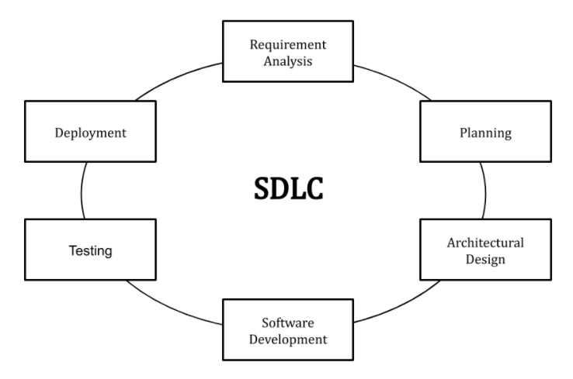

Figure 1: SDLC model

Properly completed SDLC enables the highest level of administrative control and documentation. This is why SDLC was chosen. Agile Methodologies, another research method, require several different roles to work in the project. For example, in Agile Methodologies, one of Scrum needs at least three leadership roles: Product Owner, Development Team, and Scrum Master [24]. Furthermore, traditional SDLCs are predictive SDLCs. Its requirements are well-defined and the technical risk is low. Based on the above advantages and features, it was decided to use SDLC in this development.

#### Requirement Analysis

This phase emphasizes what the system needs. The product of this phase is the SRS (Software Requirements Specification). This is a document that describes what the project does and how it is implemented [25]. The SRS must include the purpose of the system, a brief description, and specific requirements identified.

#### Planning

During the life cycle, the idea and purpose of developing the system need to be determined. This phase is designed to determine the new scope of the system and create a timeline (Gantt chart) and resource plan for the project.

#### Design

This phase aims to develop the project structure and plan based on the needs found in the previous phase. The product of this stage is the SDD (Software Design Document). SDD is different from the SRS of the previous state. SRS describes what the system function is to do, while SDD describes how the system function is implemented [26]. Additionally, the design phase includes identifying the languages and packages used to develop the system.

#### Development

The development phase is the coding phase which translates the design project plan into a real application and can be used at the production level.

#### Testing

Every completed program code requires the testing method to avoid any bugs in the application. The test that is used is called UAT (User Acceptance Testing). The client performs this test to identify the project’s goals, and whether it is matched the requirement [27].

#### Deployment

At this stage, the goal is to deploy the software to production to start using the product. However, many organizations choose to move products through different deployment environments, such as test or staging environments. This allows any stakeholder to use the product safely before placing it on the market. Additionally, this allows any eventual bugs to be caught before the product is released.

#### Work Breakdown Structure (WBS)

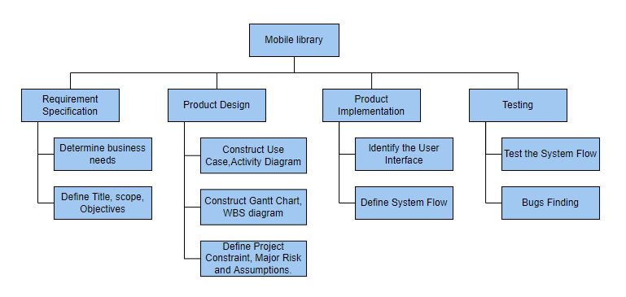

Figure 2: Work Breakdown Structure Diagram

1. WBS for Project Implementation
   1. Requirement Specification
      1. Determine business Needs
      2. Define Title, scope, Objectives
   2. Product Design
      1. Construct Use Case, Activity Diagram
      2. Construct Gantt Chart, WBS diagram
      3. Define Project Constraint, Major Risk and Assumptions
   3. Product Implementation
      1. Identify the User Interface
      2. Define System Flow
   4. Testing
      1. Test the System Flow
      2. Bugs Finding

#### Gantt Chart == Major Milestone

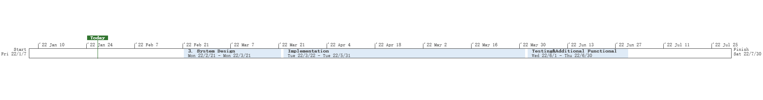

Figure 3: Project TimeLine.

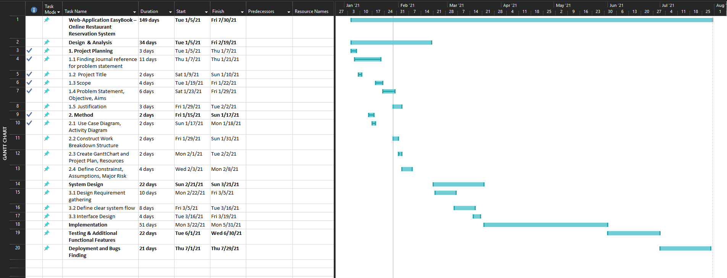

Figure 4: Project Gantt Chart

#### Project Plan

|  |  |  |  |
| --- | --- | --- | --- |
| Task Name | Duration | Start | Finish |
| **UCSI Mobile Library - Mobile Library Management System** | **147 Days** | **Fri 22/1/7** | **Sat 22/7/30** |
| **Design & Analysis** | **25 Days** | **Fri 22/1/7** | **Thu 22/2/10** |
| 1. Project Planning | 2 Days | Fri 22/1/7 | Sun 22/1/9 |
| 1.1 Finding Reference | 9 Days | Sun 22/1/9 | Wed 22/1/19 |
| 1.2 Project Title | 2 Days | Mon 22/1/10 | Tue 22/1/11 |
| 1.3 Scope | 4 Days | Tue 22/1/18 | Fri 22/1/21 |
| 1.4 Problem Statement, Objective, Aims | 5 Days | Sat 22/1/22 | Thu 22/1/27 |
| 1.5 Justification | 3 Days | Thu 22/1/27 | Sat 22/1/29 |
| **2. Method** | **10 Days** | **Sat 22/1/15** | **Thu 22/1/27** |
| 2.1 Use Case Diagram | 2 Days | Mon 22/1/17 | Tue 22/1/18 |
| 2.2 Construct Work Breakdown Structure | 2 Days | Thu 22/1/27 | Fri 22/1/28 |
| 2.3 Create Gantt Chart and Project Plan, Resources | 2 Days | Sun 22/1/30 | Mon 22/1/31 |
| 2.4 Define Constraints, Assumptions, Major Risk | 4 Days | Tue 22/2/1 | Fri 22/2/4 |
| **3. System Design** | **21 Days** | **Mon 22/2/21** | **Mon 22/3/21** |
| 3.1 Design Requirement gathering | 10 Days | Tue 22/2/22 | Sat 22/3/5 |
| 3.2 Define Clear System Flow | 9 Days | Sat 22/3/5 | Wed 22/3/16 |
| 3.3 Interface Design | 4 Days | Wed 22/3/16 | Sat 22/3/19 |
| **Implementation** | **51 Days** | **Tue 22/3/22** | **Tue 22/5/31** |
| **Testing & Additional Functional Features** | **22 Days** | **Wed 22/6/1** | **Thu 22/6/30** |
| **Deployment and Bugs Finding** | **21 Days** | **Fri 22/7/1** | **Fri 22/7/29** |

Table 1: Project Plan

## Constraints and Assumptions

The project will not be developed on any high spec physical servers. This project will only use a normal PC as the base server for the application. The project requires each user to have a smartphone for things like borrowing books. The user account password of this project is not encrypted using any complicated algorithm. In addition, the project requires no additional implementation costs.

Assumption of this project:

* It is assumed that all users have smartphones to access the network.
* All users are assumed to have basic knowledge of using a smartphone.

## Resources

### Hardware

**Computer:** This project requires a fully functional computer as it requires prototyping and documentation of the proposed mobile application.

* **Model: MSI GP76（17.3-inch，2021）**
* **Processor: 2.3GHz 8-core Intel Core i7 processor**
* **OS: Windows10**
* **Memory: 16 GB 3200 MHz DDR4**
* **Graphics: NVIDIA GeForce RTX 3070**

### Software

* **Microsoft Word**
  + Microsoft Word is used to write the project report and research findings.
* **Microsoft Project**
  + Microsoft Project is used to generate the Gantt chart diagram and project plan
* **Google Browser**
  + Browser is used to search for relevant journal research
* **Visual Paradigm Online**
  + A tool to construct UML diagram, ERD diagram, etc.
* **MySQL**
  + MySQL is a database used to store user and administrator details.
* **Android Studio**
* Android Studio is used to implement the mobile terminal.
* **IntelliJ IDEA**
* IntelliJ IDEA is used to implement the management side.
* **HBuilder X**
* HBuilder X is used to edit Android code.

## External Bodies Involved

When the performance development of the mobile Library project is relatively complete, it will work with UCSI University Libraries.

# CHAPTER 2: INFORMATION GATHERING

## Chapter Introduction

The content of this chapter is to introduce the information collection of the work related to this study. The literature review (in section 2.2) of the work related to this research topic mainly includes four aspects, The existing research on the application of library management systems and its value creation(in section 2.2.1), The influence of Internet technology on the current library management model (in section 2.2.2), The limitations of traditional library management model (in section 2.2.3), The impact of the combination of PC and mobile terminals on the current library management model under the Internet background (in section 2.2.4), and then we discussed and compared the existing mobile library management systems, and then we introduced and discussed the proposed The system, It also introduces and analyzes the book review procedures with the advantages of this study. It ends with a summary of the chapter.

## Literature Review

### 2.2.1 The existing research on the application of library management system and its value creation

There are many studies on library management systems, with a wide range of academic results. This includes not only the research on the library management system combining PC and mobile terminals but also the solution of library management problems from the perspective of the Internet of Things.

A. Larsan Aro Brian，from College of Engineering Guindy, University Departments of Anna University，Chennai, Tamil Nadu, India. The system proposed by the author is a library management system based on the Internet of things, which can display the location of books on mobile phones to prevent dislocation and loss of books. It can track books, which will greatly reduce the time for administrators to search books, and reduce the cost of lost books [28].

The paper by C. Srujana and B. Rama Murthy proposes the use of MATLAB to develop an RFID-based library management system. This RFID technology also provides self-convenience to efficiently check library staff and unreturned books. To quickly create better service quality, and more convenience for library management [29].

### 2.2.2 The influence of Internet technology on the current library management model

Since the explosion of Internet technology, many libraries have moved in the direction of digitization [30]. At the same time, all countries are encouraging traditional industries to introduce new Internet technologies for reform and innovation. Libraries are a kind of social public resource. The integration of Internet technology in daily management work can not only transform the book management model from artificial to intelligent, but also effectively improve the overall service quality of the library. The introduction of modern Internet technology in library management can also complete the reform and innovation of the traditional single service model [31].

**2.2.2.1 The Influence of Internet Technology on Book Management**

The emergence of Internet technology has brought earth-shaking changes to the library, which converts the traditional book information into data and stores it in the database. And visualize the data to make people's book information clearer [32]. This will be great for managing books. The book information management system based on contemporary Internet technology can store a large amount of book-related information, and can effectively control the cataloging, circulation, retrieval, and reservation of corresponding books with the help of mathematical model processing functions [33]. However, it should be noted that in the practical application of the system, to effectively ensure that the staff can complete the correct decision on the information, obtain the information in time, and enable the information to be transmitted smoothly, the relevant personnel need to respond to and maintain the dynamic information of the library management system in time.

**2.2.2.2 The Influence of Internet Technology on Book Management Time**

In today's era, Internet technology has penetrated all walks of life, and library management is no exception. Based on this, how to guide users reasonably so that users can accurately find the documents and materials they need in a short time is the most urgent content in library management [34]. The rise of network technology has enabled a large number of documents to be digitized [35]. There are problems with diversification and quantification of this kind of digitized literature information resources so that the corresponding staff of book management need to make reasonable adjustments to the time to filter out the content and junk information that are irrelevant to the search content for readers, thereby effectively improving The corresponding reading experience of the reader.

**2.2.2.3 The Influence of Internet Technology on Book Resource Management**

Libraries generally store a large number of literature resources. The Internet technology has enriched the management of book resources. It converts many documents into electronic versions and stores them in databases and the cloud [36]. This will make book resources more secure. Therefore, libraries in the new era that introduce network technology should give full play to their advantages in relevant resources. Effective resources are systematically integrated and scientifically evaluated. At present, all major libraries have established a relatively comprehensive literature resource library, and the resource integration, development and publishing systems have also been configured accordingly [37]. Relying on the existing platform, library managers can screen resources on the network, and can combine the screened resources with existing resources, so that the library's collection resources can be effectively integrated and tend to be diversified. At the same time, adopting this method can satisfy users' response to various types of information to a certain extent, and can improve the utilization rate of resources in the library while expanding the search for resources.

### 2.2.3 The limitations of traditional library management model

Judging from the development history of the library, it is generally believed that the library has experienced three development periods: the period of the ancient private library and the official library, the period of the modern traditional library and the period of the modern library that we are currently working on [38]. The traditional library mainly refers to the library before the 1950s. It is a cultural and educational institution that collects, organizes, keeps, and uses books and periodicals to serve readers. Its functions are: 1.Preserving cultural classics; 2.Providing lending services. Its characteristics are: the collection of books is mainly printed on paper, the information of the collection is reflected through the card catalogue and retrieval publications, the information is transmitted through the readers to the library and the books are delivered to the door, and the arrangement and circulation of books are mainly manual operations.

Traditional library management tends to be organized and institutionalized, and its form is relatively simple. It is basically a traditional document information management model for the purpose of collecting and protecting books, and it has limitations in time, space, content, method and quantity [39].

First, the collection of paper books takes up a lot of space, and it is difficult to find documents quickly and easily. There is no way for the library to understand the various needs of readers in time, and the personalized customization and professional services for readers are not enough, resulting in low satisfaction of teachers and students.

Second, in the traditional library, readers must rely on reaching the library to complete and achieve the purpose of borrowing books, reading, and obtaining information, while the university library, which is mainly based on manual services, has limited opening hours and cannot provide 24-hour management and services. , the limited working time can not meet the real needs of readers.

Third, the traditional physical library is relatively solid in its organizational structure and management system, its job responsibilities are relatively clear, the division of labor among various departments is fine, and the connection between specific work and services is not close enough. In terms of information push, it is basically in a state of mutual isolation and less cooperation, it is difficult to form a unified service concept, and it is impossible to take advantage of the overall advantages and exert the synergy of the platform.

Fourth, the content of library services is limited. The processing of traditional library documents is carried out by the staff according to the process, according to the process of collection, registration, storage, arrangement, circulation and reading. It mainly provides some shallow basic materials, and the field of information collection is not enough. Comprehensive, can not get all kinds of urgently needed information or the latest information in the shortest time. Librarians can only provide general consulting and answering services, which cannot meet the needs of readers.

### 2.2.4 The impact of the combination of PC and mobile terminals on the current library management model under the Internet background

Under the library management mode that combines PC and mobile terminals, readers can timely learn about the status of some relevant library collections through mobile terminals, and can also refer to information and supporting reader services through such a customer service port, and extend to some online games and informatization quality training of readers. Virtualized management and services save a lot of resources for the library in the process of management, especially time and space resources [40]. In this way, readers can break the time and space restrictions, and can check the specific collection status of the library at any time, and communicate with some online network service personnel of the library, to rely on the mobile Internet to improve readers and The connection between libraries promotes the interaction between libraries and readers.

## 2.3 Discussion & Comparison

### 2.3.1 Existing mobile library management system

There are many mobile library management systems. This section will compare and discuss those existing mobile library management systems with the applications implemented in this project.

|  |  |  |  |  |
| --- | --- | --- | --- | --- |
| S.NO | Title of the Paper ( System ) | PROS | CONS | Remakes |
| 1 | Developing a QR Code-based Library Management System with Case Study of Private School in Surakarta City Indonesia. | It reduces the lengthy borrowing process, membership, and collection checks[41]. | It needs good camera quality to protect from scratches. | Scanning each QR code is difficult when there are many users present. |
| 2 | The university library management system is based on radio frequency identification. | This system studies the label conversion and self-service borrowing subsystem[42]. | Authentication and authorization are required. | It's more of a QR code system, but not for more users. |
| 3 | Design and realization of network-oriented library management system(LMS). | It is a network LMS that works on its private network[43]. | It can only be operated from a computer. | The library cannot be used when the system is out of power. |
| 4 | Designing Android User Interface for University Mobile Library. | Users can perform actions anywhere[44]. | Only users can do it anywhere, while librarians need it on a computer. | Need to allow administrators to manage the application as well. |
| 5 | The Building of Library Management System Based on Hibernate Model. | Using Flex as the presentation layer, hibernate as the persistence layer, and Spring as the business layer, an efficient library management system is realized[45]. | Only suitable for web applications. | The cross-platform compatible framework is recommended. |
| 6 | VESIT Library -An android based application. | Android app with SQL database server helps students view all library collections[46]. | When the library is down, the application server is unavailable. | It needs to be implemented to run anytime and anywhere. |

Table 2: Comparison of existing mobile library systems

From the table above, we can see that a QR code-based library management system reduces the lengthy borrowing process, membership and collection checks [41]. But it requires good camera quality, and scanning QR codes is difficult when there are many people.

The library management system based on radio frequency identification studies the label conversion and self-service borrowing subsystem [42]. The inconvenience lies in need for authentication and authorization, which is not suitable for more users.

The network-oriented library management system works on the private network LMS [43]. But the system only works on the computer. After the system is shut down, the library will not be available.

For the library system with Android user interface, users can use the system anywhere [44]. But the administrator can only use the system on the computer, which causes great inconvenience.

The library management system based on the hibernation model uses Flex as the presentation layer, hibernation as the persistence layer, and Spring as the business layer to realize an efficient library management system [45]. But it is only suitable for Web applications.

The VESIT library can help students view all library holdings by using a server with an SQL database [46]. But when the library is closed, the application server will not be available. It needs to run anytime, anywhere.

### 2.3.2 Proposed the mobile library management system

The mobile library system in this study is developed based on the Android platform. It allows users to operate anytime, anywhere. This not only reduces people's reliance on computers but also saves people's time. Users do not have to go to the library to make inquiries and reservations. The system features book reviews, where users can share their thoughts on books and exchange ideas with each other. Through the book review function, students can also give feedback on the relevant situation of the book, such as damage, missing pages, etc. The situation of the library can also be reported to the management through this channel. The system realizes the interactive management between librarians and users through the functions of book reviews and announcements. This will foster the relationship between the two and create a virtuous circle for the library.

### 2.3.3 Book Review Plan

According to the mobile library management systems in the comparison table, they do not introduce a book review program into their system to enhance the user experience. Therefore, this project introduces the book review scheme. Most mobile library management systems only focus on the functions of the library itself and research book loss prevention. They all ignore the crucial importance of interactive management of the library [47].

The mobile Internet management of the library is an interactive management method. In fact, the mobile management of the library needs to be considered comprehensively, especially in the development of mobile APPs, which should be actively explored, arouse the enthusiasm of readers in various ways, and encourage readers and the library to communicate with each other, to make the library truly able to serve readers [48]. The Book Review Plan can do just that, allowing users to exchange their thoughts on books through book reviews. Users can also use this channel to report the relevant situation of the book to the librarian, such as missing pages, damage, etc., so that the books can be better maintained and updated. Users can also communicate with the management through book reviews to reflect the situation of the library, so that everyone can better maintain the library.

Library services play an important role in user satisfaction [49]. If the service of the library is good, it will form a virtuous circle. In the Book Review Program, users express praise and compliments for the good service the librarian has done. Librarians will see his compliments directly through book reviews, which will motivate librarians to work more seriously and bring a better experience to the library and users. This will form a positive cycle, which is conducive to the healthy development of the library.

The library management in the mobile Internet era should have some new thinking. Only by using new thinking can some practical problems be solved. Therefore, it is necessary to innovate the management thinking and management mode. Realize the overall improvement of library management.

## Chapter Summary

In conclusion, this chapter introduces the literature survey related to this research topic, analyzes and compares existing mobile library management systems, and then I introduce the system of this research and introduce and analyze the book review program that features the characteristics of this research advantage. It ends with the summary of this chapter.

**CHAPTER 3: ANALYSIS**

## 3.1 Chapter Introduction

To determine the current state of the system to be developed, we use a pre-developed questionnaire, first we explain the sample size and target participants of the survey (in Section 3.2), then we analyze the results obtained from the questionnaire and summarize, including an analysis of the demographic characteristics of the respondents (section 3.3), Analysis of people's expectations and cognition-related issues for the new library management system (section 3.4), and The scale questionnaire analysis of library management system requirements related issues. (section 3.5) , and finally our conclusions are based on the investigation of this chapter, which is presented in the chapter summary (in Section 3.6).

## 3.2 Online Survey

In this study, a random questionnaire will be used. The study will randomly select 120 respondents from UCSI University to obtain system requirements and customer preferences. In order to obtain more accurate survey results, some abnormal data will be deleted to avoid affecting the accuracy of the results. In addition, the survey will be released on Twitter, Facebook and other social media, and the questionnaire will be conducted in the form of Google form and data analysis.

## 3.3 Respondent information characteristic analysis

**3.3.1 Age**

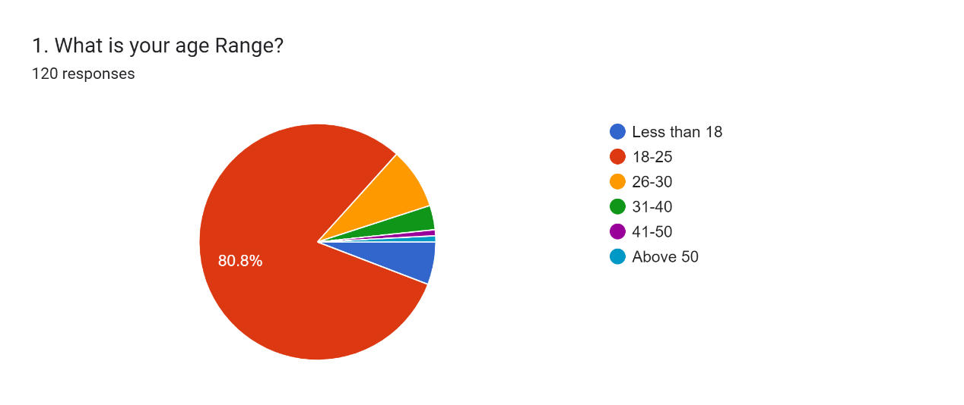

The pie chart shows the age distribution of the respondents to this survey, we can clearly see that 80.8% of the respondents are aged 18-25, which is the highest proportion. 8.3% of respondents were between the ages of 26-30 and 5.8% were younger than 18. In contrast, only a small percentage of respondents were 31 and older. So my conclusion from this chart is that in the context of current new developments, the main group that the library serves is the under-31 group. It can be seen that the public environment facing the library management system is mostly young groups. This will help us to popularize intelligence, and the hardware requirements of the system to complete this study in the context of having mobile smartphones. And the younger group will be more likely to accept novel operation methods and new changes.

**3.3.2 Gender**

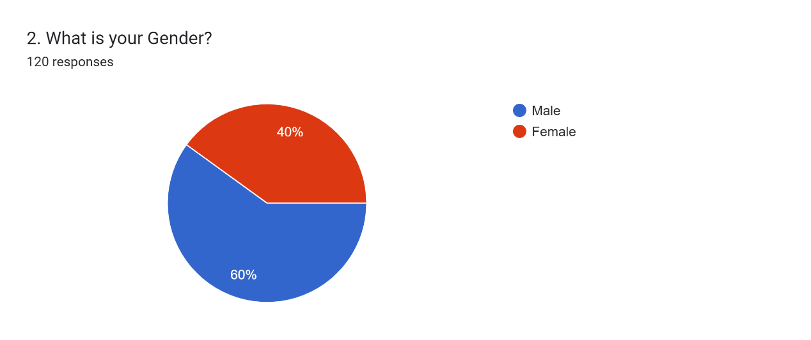

This pie chart compares the gender distribution of respondents, and it is clear that 60% of respondents to the survey were male, the highest percentage, compared to 40% female. From this data, it can be concluded that the ratio of male and female users in the library is not much different now, so when we study the system design style preferences, we can design it to be neutral to cater to the preferences of all users.

**3.3.3 Role**

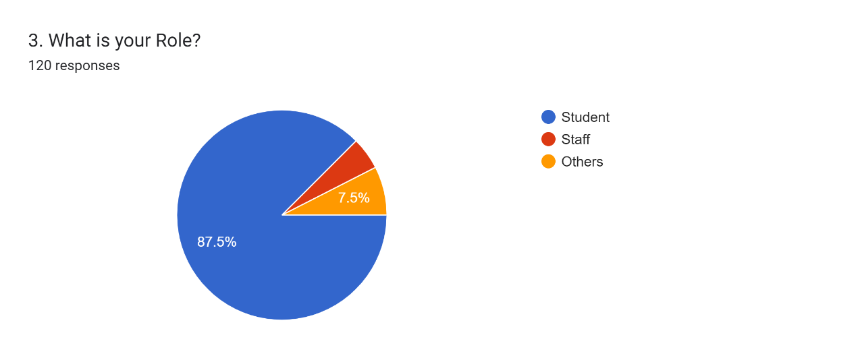

The pie chart compares the distribution of the roles of the respondents, it is obvious that among all the respondents in the survey, we can see that 87.5% of the respondents are students, who, as the largest learning group, are the most important in the library user of. In comparison, the staff only has 5%, and the rest account for 7.5%. From the above data analysis, this study can conclude that the main users of the library are still students. Therefore, when we develop the system, we can develop more in the style of students. Of course, the preferences of other groups also need to be considered.

**3.3.4 Educational Background**

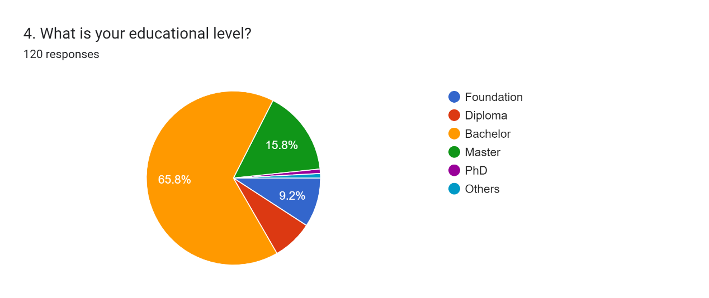

This pie chart compares the educational background of the respondents. Among the total respondents of the survey, we can see that the bachelor’s degree accounts for the highest proportion of the respondents, reaching 65.8%. This was followed by respondents with a master's degree at 15.8%. That compares with just 9.2% of respondents to Foundation, 7.5% to Diploma, and 1% to those with a Ph.D. The conclusion that can be seen from this figure is that the educational level of current library users is relatively high, which will help us promote the new library management system.

**3.3.5 Country / Region**

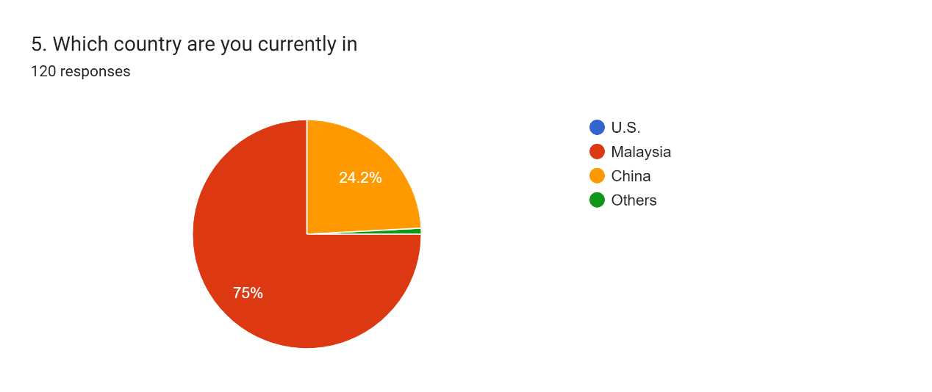

This pie chart shows the number of respondents from each country as a percentage of the total respondents in the sample. As the survey was mainly conducted in Malaysia and China, 75% of the respondents were from Malaysia, followed by China with 24.2%.

## 3.4 Analysis of people's expectations and cognition-related issues for the new library management system

**3.4.1 The purpose of users going to the library**

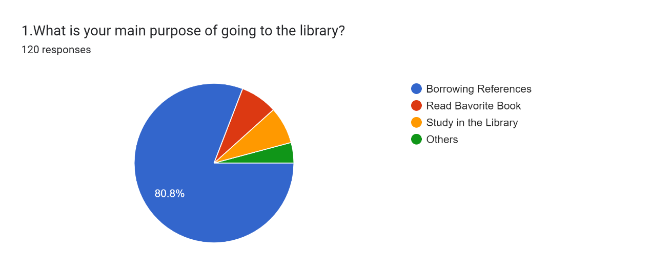

This pie chart shows the purpose of people going to the library. This questionnaire has 4 options, among which the number of respondents who go to the library to borrow reference materials is the largest, accounting for 80.8%. This was followed by reading favorite books and studying in the library, both accounting for 7.5% of respondents. The rest went to the library for other purposes, accounting for 4.2%. According to the above data, we can analyze that the main purpose of people going to the library is to borrow books (reference materials). Therefore, we can conclude that the main function of the new library management system can focus on borrowing books.

**3.4.2 Public perception of the new library management system**

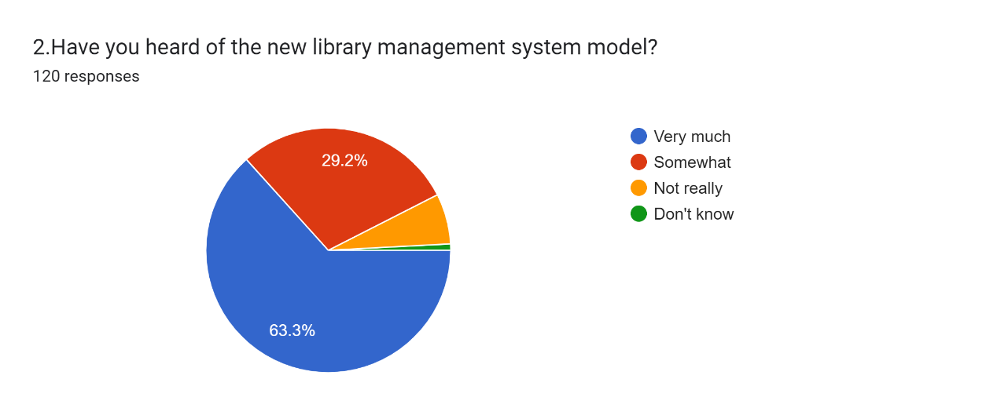

This pie chart shows all respondents' awareness of the new library management system. We can clearly see that the majority of respondents know a lot about the new library management system, accounting for 63.3, which is more than half of the total respondents. And 29.2% of the respondents said they knew a thing or two about the new library management system, and 6.7% of the respondents said they had not heard much. From this, it can be concluded that with the development of mobile phones and intelligent apps, the new library management system is gradually accepted as a major innovation in modern library management systems and is now well known by many people.

**3.4.3 Public perception of the library management system model combining Android mobile devices and PCs.**

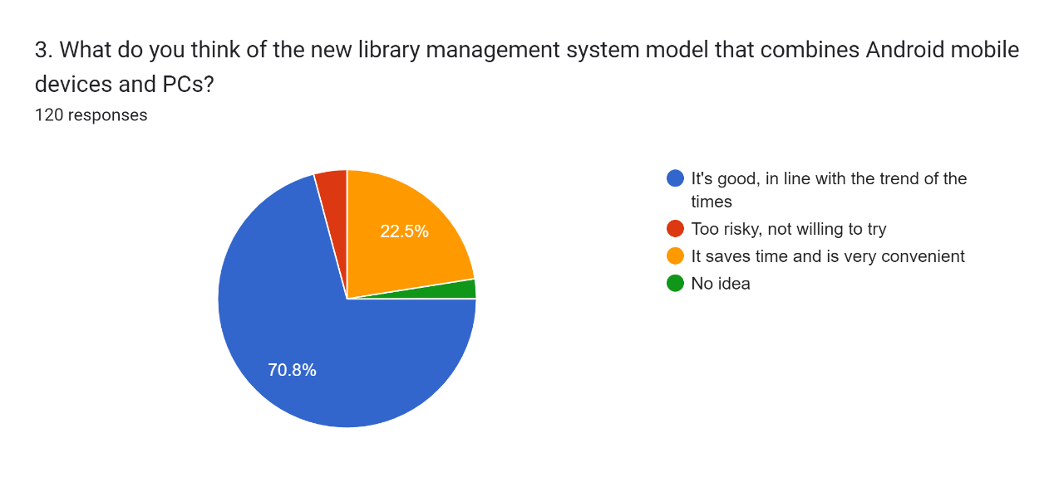

This pie chart shows how all respondents in the survey felt about the Android mobile device and PC combined library management system model. The majority of respondents believe that the combination of Android mobile devices and PCs is a good idea, which caters to the trend of the times, accounting for 70.8%. And 22.5% of the respondents thought it would help them save time and be very convenient. In contrast, however, a small number of 4.2% of respondents said they were afraid to try this new Android mobile device and PC combined model. A smaller number of respondents said they did not know. Based on the above data, we can conclude that although some users are conservative and afraid of accepting new things, the combination of Android mobile devices and PCs is being accepted by the public. Everyone hopes to improve the operating efficiency of the library and save time through reform and innovation.

**3.4.4 The view of advantages of a library management system that combines mobile Android devices and PCs over a library management system that can only run on PCs.**

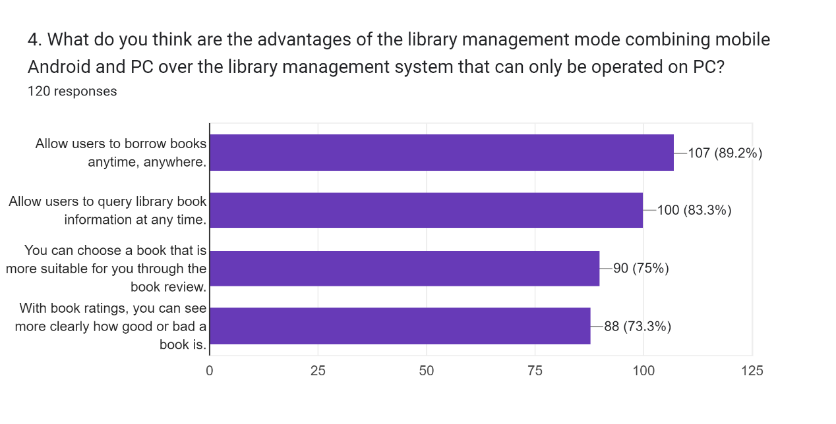

This horizontal bar graph represents all respondents' perceptions of the advantages of a combined mobile Android device and PC management system over a PC-only library management system. 89.2% of them believe that the library management system based on mobile terminals can allow users to borrow books at any time and anywhere. 83.3% of the respondents believe that the system allows users to inquire about the books they want to inquire at any time, because the traditional library management system requires users to be in the library to inquire and perform borrowing operations. 75% of the respondents believe that the book review function of the system can help them choose the books they want and the books they need. Because the traditional library management system does not have a book review function, it makes it difficult for users to communicate directly and express their views on books. 73.3% of the respondents said that the book rating mechanism of the system can help them judge whether the book is good or not. Because of the existence of the scoring mechanism, it can show the reader's satisfaction with the book, and can be used as a judgment criterion for user selection. We can conclude that users are very concerned about efficiency issues, and it is a requirement for users to select their favorite books more accurately. Therefore, the library management system I developed based on the combination of a mobile terminal and PC terminal will have functions such as book reviews and scoring. Users can query book information anytime and anywhere on Android mobile devices, and perform operations such as borrowing. Provide users with a better experience.

**3.4.5 The Survey on the Acceptance Level of New library management system**

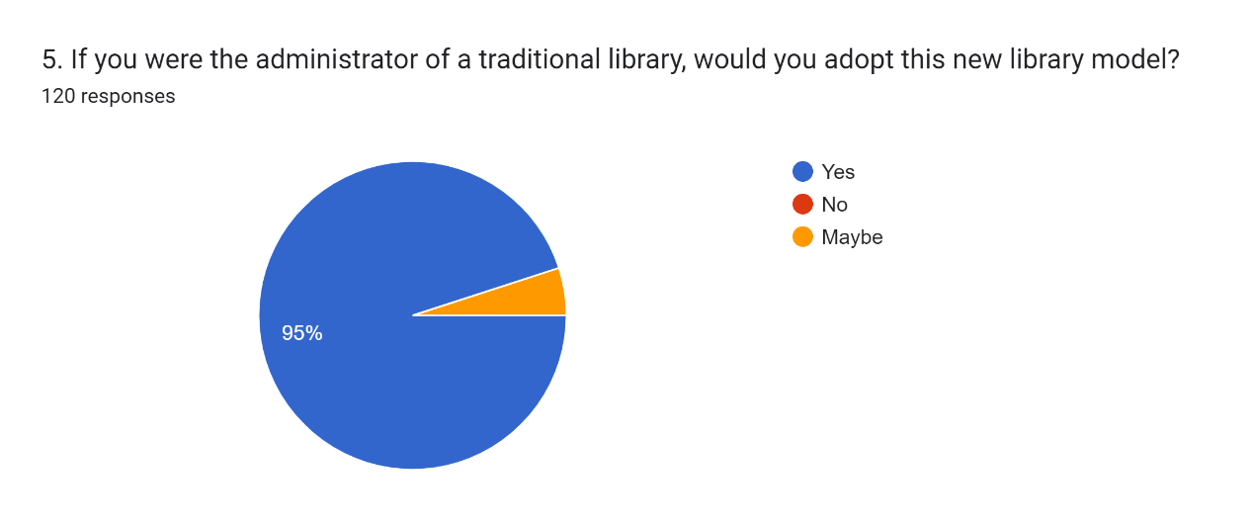

This pie chart shows the survey respondents' acceptance of the new library management system combining Android mobile terminals and PC terminals. Clearly, 95% of respondents would be willing to adopt this new library management system, and 5% said they would likely adopt this new library system. So we can conclude that most people are willing to accept the new management system model. This will help us develop and popularize the library management system.

**3.4.6 The views on the future of the new library management system.**

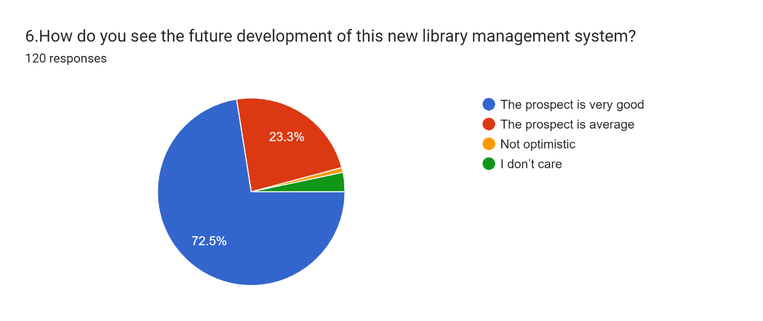

This pie chart shows how respondents in the survey see the future of the new library management system. Here, we can clearly see that the majority of respondents believe that the future of this new library management system is very good, accounting for 72.5%. 23.3% of the respondents believe that the future of the new library management system is average. And 3.3% of respondents said he doesn't care what the future holds for the new library management system. So, from this graph, we can draw conclusions. Most people are very optimistic about the prospects of this new library management system model, although the current technology development is not particularly mature. But in my opinion, with the continuous popularization of mobile phones and the continuous development of the Internet, this new library management model will become the mainstream system.

## 3.5 The scale questionnaire analysis of library management system requirements related issues.

**3.5.1 Statement: “I think traditional library management relies too much on manual operation control, which is not only difficult to operate, but also inefficient.”**

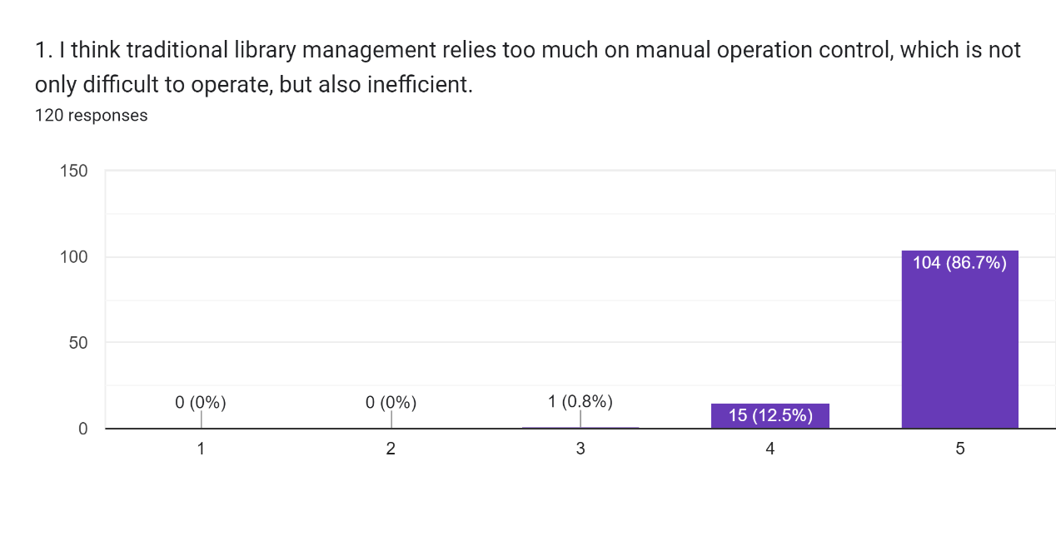

This linear scale indicates that respondents agree to vary degrees with the statement that "I think traditional library management relies too much on manual operation control, which is not only difficult to operate, but also inefficient." We can clearly see that the majority of respondents strongly agree with this statement at 86.7%, 12.5% agree with this statement, and no respondents disagree with this statement. From this chart we can conclude that at present most people feel that traditional library management is often inefficient, therefore, the library management application that I will develop will be considered to provide a more efficient way for traditional libraries to Replace inefficient traditional models for better library management.

**3.5.2 Statement: “I think traditional libraries rely too much on a single lending method.”**

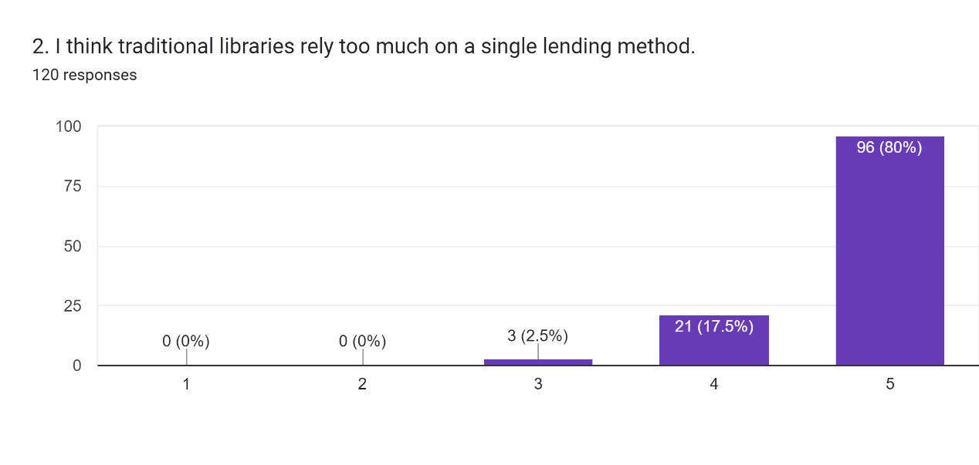

This linear scale indicates that respondents agree with the statement "I think traditional libraries rely too much on a single lending method" to varying degrees. We can clearly see that most of the respondents strongly agree with this statement, accounting for 80%, 17.5% agree with this statement, and 2.5% say they have a neutral attitude towards this statement. From this chart we can conclude that most people feel that the traditional library lending method is too monolithic. Therefore, the library management system application I developed will enrich the borrowing methods, which can be borrowed on the mobile terminal. This will bring great convenience to the user and greatly reduce the operation time of the administrator.

**3.5.3 Statement: “I think the book statistics of traditional libraries are prone to misjudgment.”**

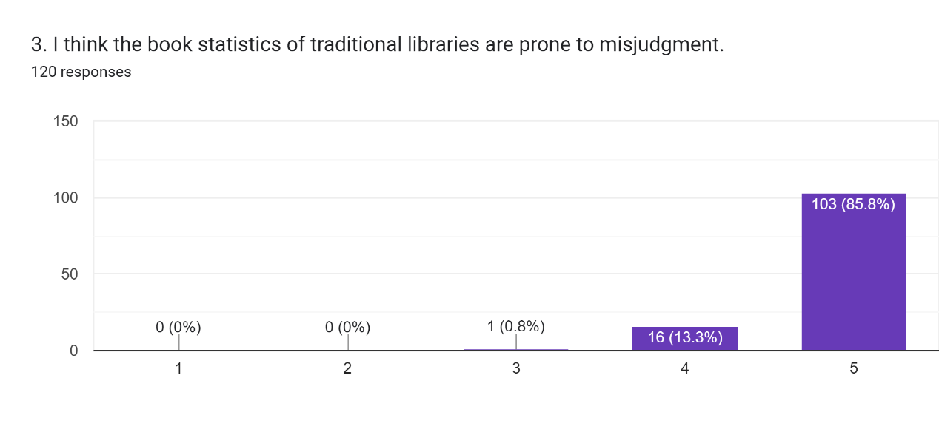

This linear scale indicates the degree to which all respondents agreed with the statement "I think the book statistics of traditional libraries are prone to misjudgment". Here, we can clearly see that the majority of respondents strongly agree with this view, accounting for 85.8% of all respondents, while a minority of respondents, 3.6%, agree, and no respondents disagree. It can be seen from this chart that in the current traditional library management, since business operations are mostly manual operations, it is easy to cause errors in the calculation of book inventory statistics, and the error in the number of books is a major problem. The management that many libraries face question. Therefore, the solution I provide is to develop the real-time entry and update function of book information through the system to help improve the efficiency of library management and make it easier for administrators to manage the library.

**3.5.4 Statement: “I want tools that can help me improve my book lending efficiency.”**

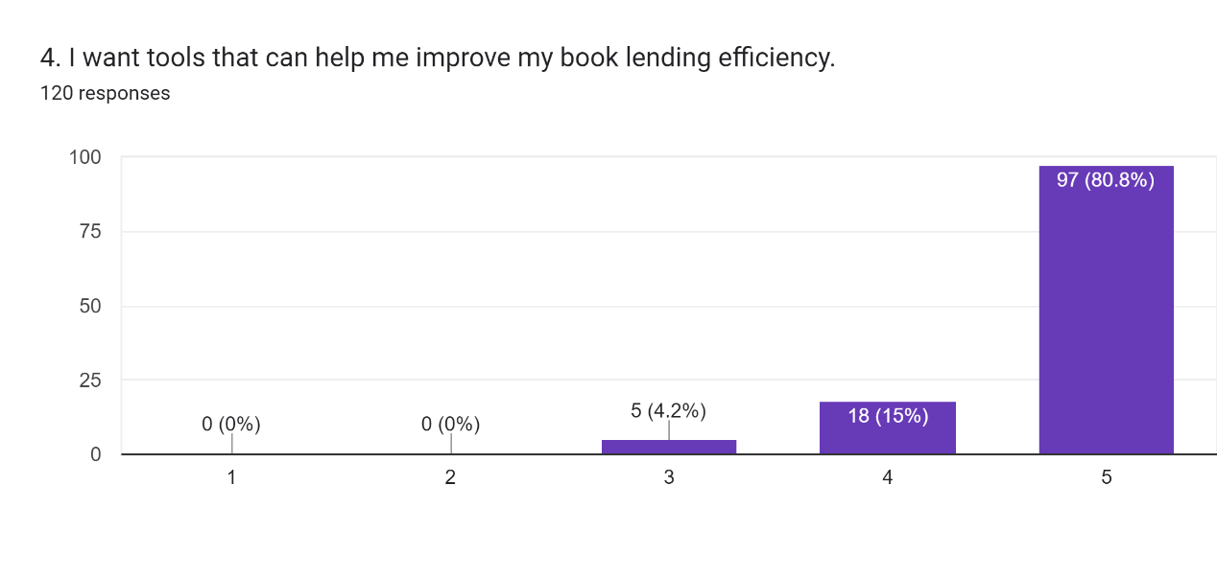

This linear scale indicated that respondents agreed with the statement "I want tools that can help me improve my book lending efficiency" to varying degrees. We can clearly see that the majority of respondents strongly agree with this statement at 80.8%, 15% agree with this statement and 4.2% are neutral to this statement. From this chart, we can conclude that the current library borrowing efficiency is often low, and most people want a better tool to help them borrow books and improve their borrowing efficiency. Therefore, the library management application I will develop will provide users with more efficient lending.

**3.5.5 Statement: “I hope that the library management system can be carried out through mobile devices to adapt to the future development environment.”**

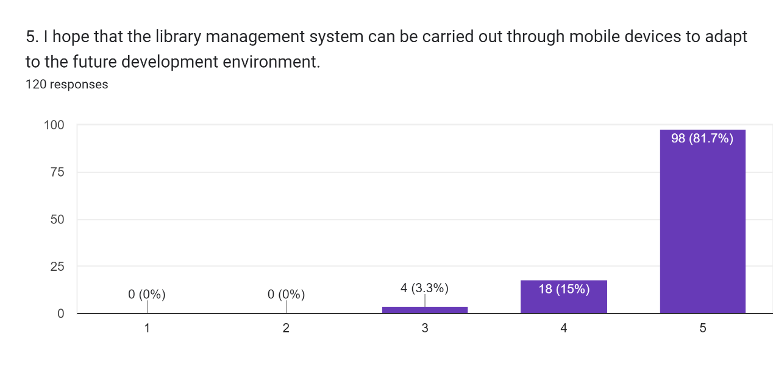

This linear scale indicated that respondents agreed with the statement "I hope that the library management system can be carried out through mobile devices to adapt to the future development environment" to varying degrees. We can clearly see that the majority of respondents strongly agree with this statement, accounting for 81.7%, 15% of respondents agree with this statement, and 3.3% of respondents are neutral to this statement. From this chart, we can conclude that because the general library management method is too monotonous, most people want their library to also conduct lending management operations through mobile devices, which will help them reduce time costs. Therefore, for the store management application I want to develop, I will consider developing a mobile library management system, so that they can more easily access the library for operation, which will make the library better adapt to the future development environment.

**3.5.6 Statement: “I am not satisfied with the existing library management systems on the market.”**

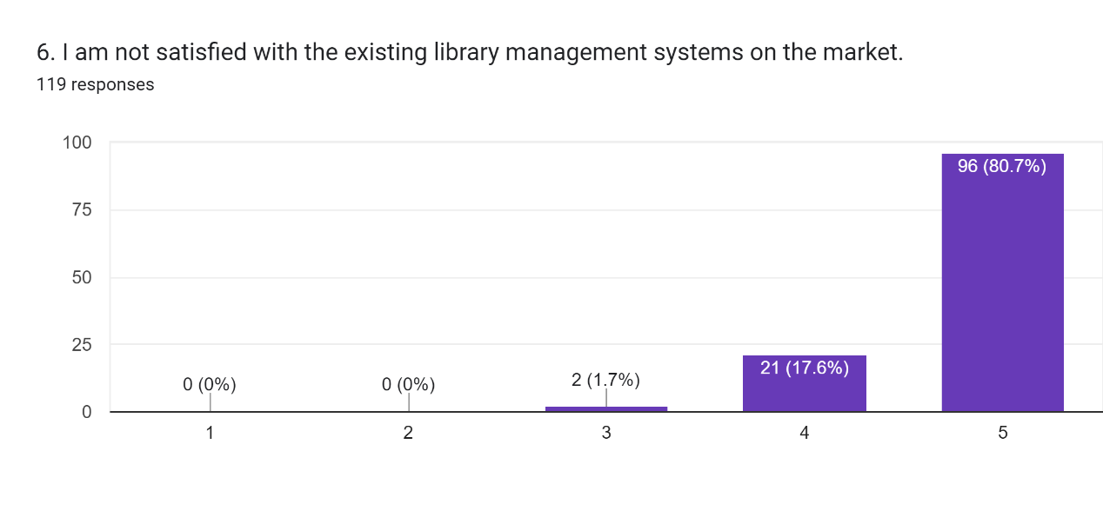

This linear scale indicates that respondents agree with the statement "I am not satisfied with the existing library management systems on the market." to varying degrees. We can clearly see that the majority of respondents strongly agree with this statement, 80.7%, 17.6% agree and 1.7% are neutral. From this chart, we can conclude that for various reasons, most people are not satisfied with the existing library management systems in the market, so for the library management application that I am going to develop, I need to consider more Multiple issues such as UI to make users and administrators more satisfied to help libraries achieve better management.

**3.5.7 Statement: “I hope that the library management application can manage the inventory information of books and update the inventory information of books in real time.”**

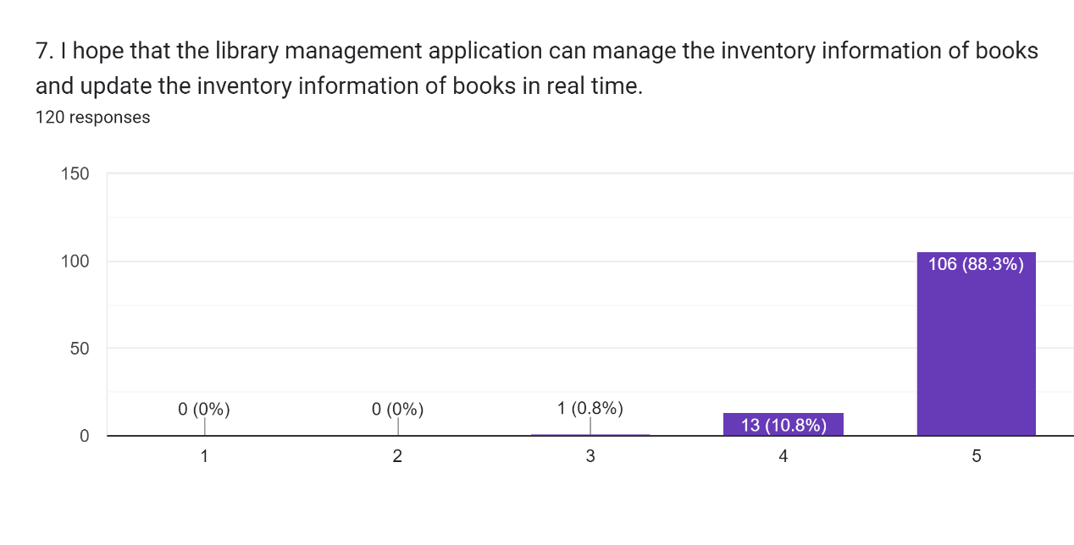

This linear scale indicated that respondents agreed to varying degrees with the statement "I hope that the library management application can manage the inventory information of books and update the inventory information of books in real time." We can clearly see that most of the respondents strongly agree with this statement, accounting for 88.3%, and 10.8% agree with this statement and have no objection. From this chart, we can conclude that since most of the inventory management is currently based on manual work, the number of books is large, and book statistics are prone to calculation errors, and more people want to use tools to help them better manage book inventory information. Therefore, for the book management application that I want to develop, I need to think of a solution for the library to develop a function for online real-time book inventory entry and update through the system. This can help librarians manage library inventory more easily and give them a clearer picture of the status of the library.

**3.5.8 Statement: “I hope library management applications can help libraries reduce management costs.”**

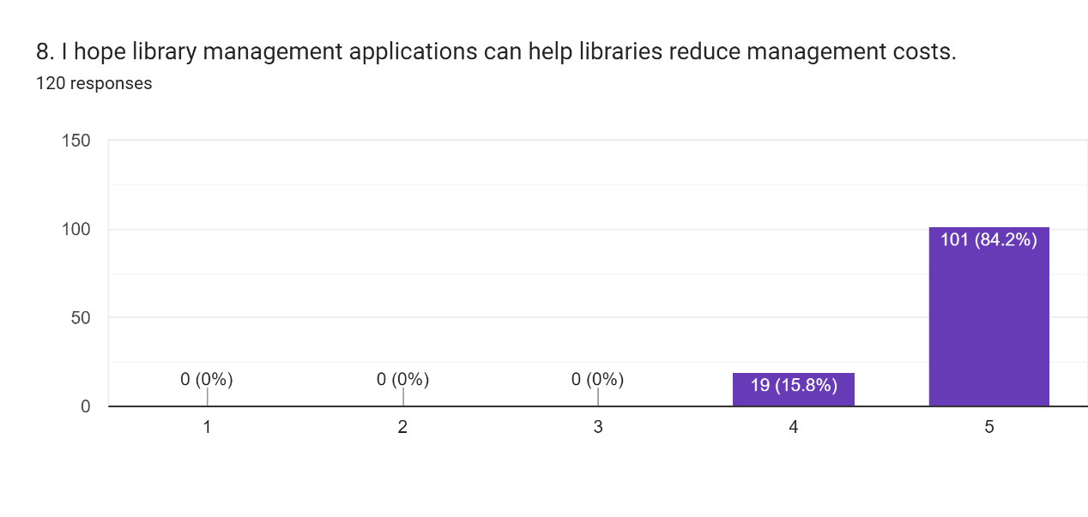

This linear scale indicates that respondents agree to varying degrees with the statement "I hope library management applications can help libraries reduce management costs." We can clearly see that the majority of respondents strongly agree with this statement, 84.2%, and 15.8% agree with this statement, with no opponents. From this chart, we can conclude that the management cost of the library is getting higher and higher nowadays, and everyone wants to reduce the management cost as much as possible. As a result, more and more people are looking for library management applications to help reduce library management costs. Therefore, for the store management application I want to develop, I need to minimize unnecessary cost waste and maximize resources.

**3.5.9 Statement: “I think library management applications should help save librarians' time.”**

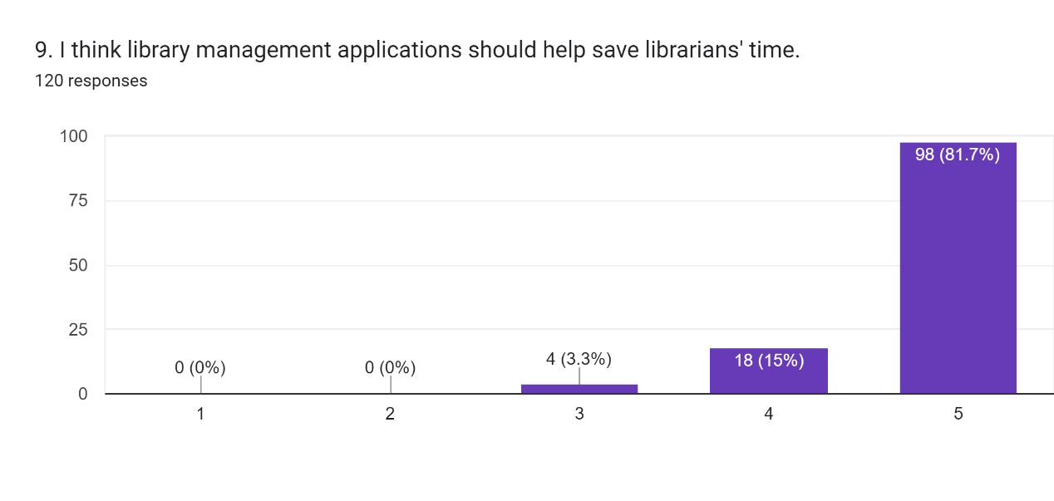

This linear scale indicated that respondents agreed to varying degrees with the statement "I think library management applications should help save librarians' time." We can clearly see that the majority of respondents strongly agree with this statement, 81.7%. 15% agreed with this statement, while 3.3% said they were neutral. From this chart, we can conclude that most respondents agree that a good library management application should help save the store manager's work time and thus librarians' time and effort . Therefore, for the library management application I want to develop, I need to transform and optimize the cumbersome book management process, help improve the management efficiency of administrators, help administrators save time and cost in management, and make the library run more efficiently.

**3.5.10 Statement: “ I think a good user interface will make it easier for administrators to manage books.”**

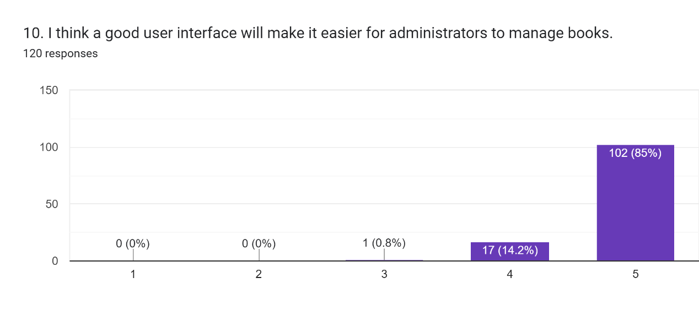

This linear scale indicated that respondents agreed to varying degrees with the statement "I think a good user interface will make it easier for administrators to manage books." We can clearly see that the majority of respondents strongly agree with this statement, at 85%. 14.2% agreed with the statement, while 0.8% said they were neutral. From this chart, we can conclude that most people want to use a library management system with a good user interface because it helps them manage their library more easily. Therefore, for the library management application I want to develop, I will consider designing a good user interface by continuously exploring the needs of users, so as to improve the administrator's experience in management operations, which is not only beneficial for the library administrator to the system It also helps to improve the operational efficiency of the library.

## 3.6 Chapter Summary

Based on this survey it can be concluded that most people want a better library management system. Most of the users are between the ages of 18-25 and have relatively high education. This will help us to promote the mobile library management system. A mobile library management system with a good UI design is required. Most people want better tools to help them manage their libraries effectively, thereby improving efficiency and reducing management costs. In addition, most people want to be able to borrow books and so on through the channels of mobile devices. The mobile library management system will help library management, and will greatly facilitate users to borrow and return books and other operations. Borrowing and other operations can be performed regardless of location and time. It will also help libraries better manage book information. This will greatly improve the management efficiency of the library and reduce the management cost of the library.

# CHAPTER 4: SYNTHESIS

## 4.1 Chapter Introduction

This chapter describes the functional and non-functional requirements of this mobile library management system application. UML diagrams (in Section 4.2) are drawn to better illustrate the requirements, including Use Case Diagrams (in Section 4.2.1) and Activity Diagrams (in Section 4.2.2). This chapter also includes Prototyping Interface (in Section 4.3), Featured Code (in Section 4.4).

## 4.2 UML Diagram

UML stands for Unified Modeling Language. It is a rich language for modeling software solutions, application structures, system behavior, and business processes. It has two main categories; Structure Diagrams and Behavioral Diagrams. The detailed categories are as follows.

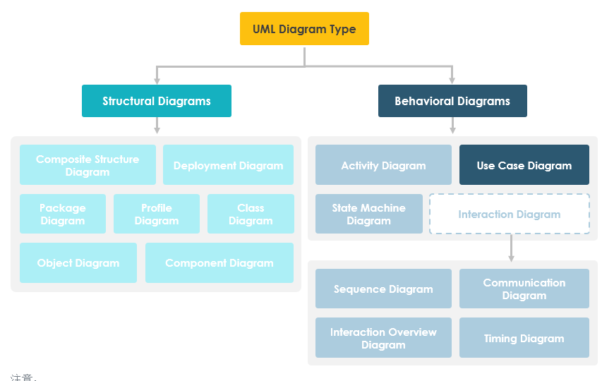

Figure 5: Classification of UML diagrams

### 4.2.1 Use Case Diagram

A use case diagram is the primary system/software requirements for an undeveloped new software program. A use case specifies the expected behavior. Once a use case is specified, it can be represented with a textual and visual representation (i.e. a use case diagram). A key concept of use case modeling is that it helps us design systems from the end user's perspective. It is an efficient technique for communicating system behavior in the user's way by specifying all externally visible system behaviors.

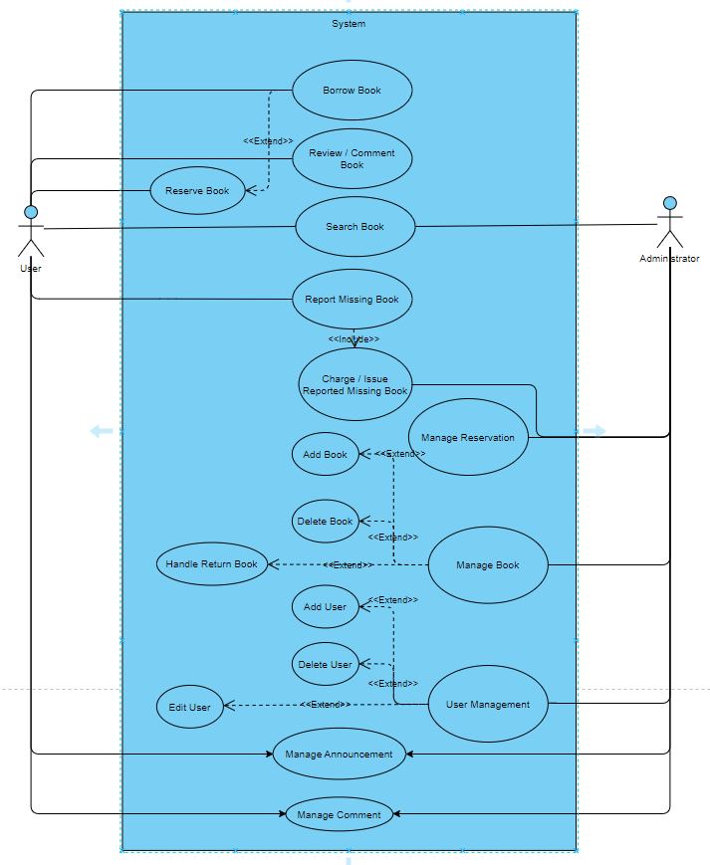

Figure 6: Use Case Diagram

This use case diagram relates to two actors (User and administrator). Users can visit the library page to order books, borrow books, review books, search for books and report missing books. Users can view announcements posted by administrators. From the administrator's point of view, the administrator can search for book information and manage reservation information. Administrators can manage book information, such as adding and deleting books. Administrators can manage user information, such as adding and deleting users. Admins can also manage the posting of announcements and manage comment information. Administrators also need to deal with missing book information.

They will have the same use cases which are search book, manage announcements and manage comment.

### 4.2.2 Activity Diagram

An activity diagram is a behavioral diagram, i.e. it describes the behavior of the system. An activity diagram depicts the flow of control from a starting point to an ending point, showing the various decision paths that exist in the execution of an activity. The activity diagram is the key and foundation of the UML software development flowchart. Project planners use this activity to describe system operating procedures one by one to make the implementation design phase clearer and easier.

The following diagram illustrates an activity diagram in a project.

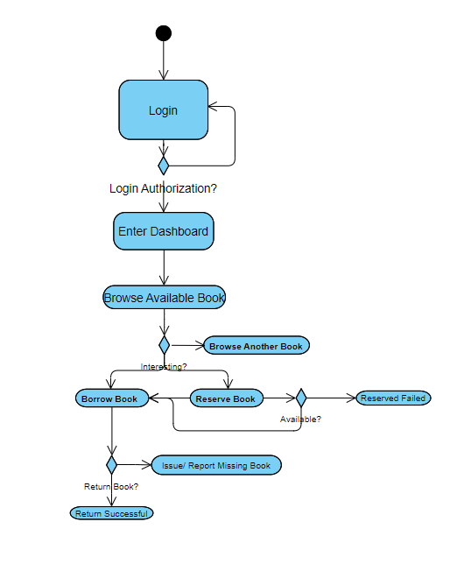

Figure 7: User Activity Diagram (Borrow Book)

Figure 7 above shows the activity diagram of a user borrowing a book. Users first need to log in to the mobile interface, and then view books that can be borrowed or view other books. When there are enough books in stock, users can borrow them directly. If there is not enough stock, the user can reserve the book, and the administrator will check whether it passes, and if it is rejected, the reservation will fail. After borrowing, the user can apply for the return of the book, and the administrator will review and determine whether the return is successful. If the book is lost, you can report the book lost.

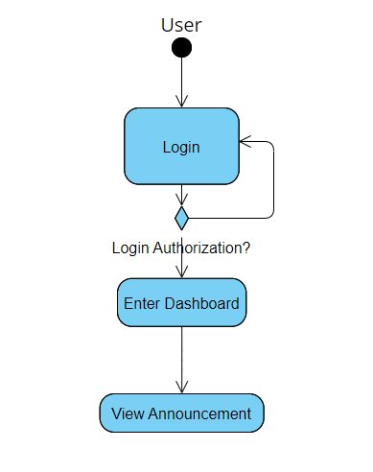

Figure 8: User Activity Diagram (View Announcement)

Figure 8 shows an activity diagram of a user viewing an announcement. After the user logs in to the mobile terminal, the system will determine whether the login is successful. After successful login, users can click on the bulletin board to view the bulletin.

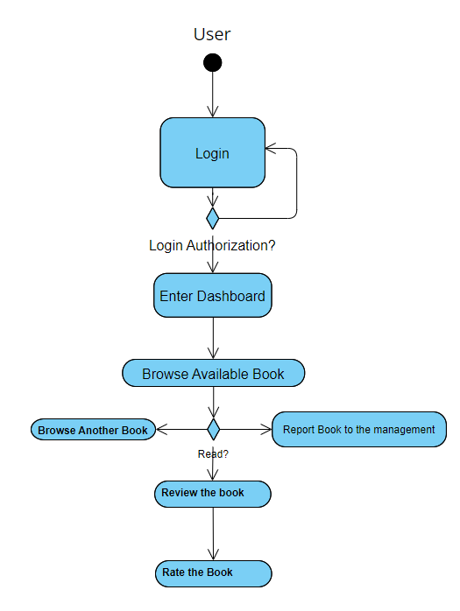

Figure 9: User Activity Diagram (Report Book)

Figure 9 shows the activity diagram of a user while browsing books. The user logs in to the mobile terminal and browses available books. Users can borrow books, or report book information or library conditions to management. Users can comment on the books they are reading, share their thoughts, etc., and then they can rate the books.

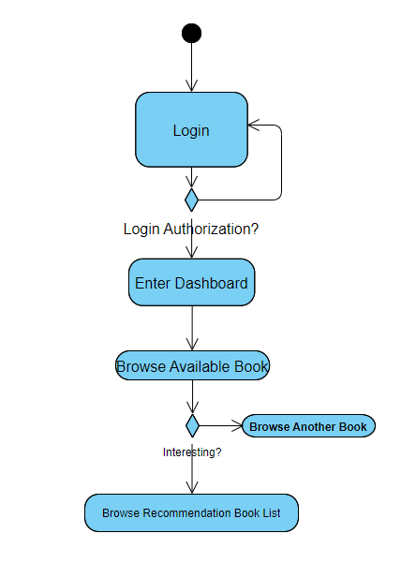

Figure 10: User Activity Diagram (Browse Recommended Books)

Figure 10 shows an activity diagram of a user browsing recommended books. The user logs in to the mobile terminal, and after the system login verification, after the login is successful, the user can browse the available books. In the Recommended Books area, if you are interested, you can browse the list of recommended books. If you are not interested, you can browse other books.

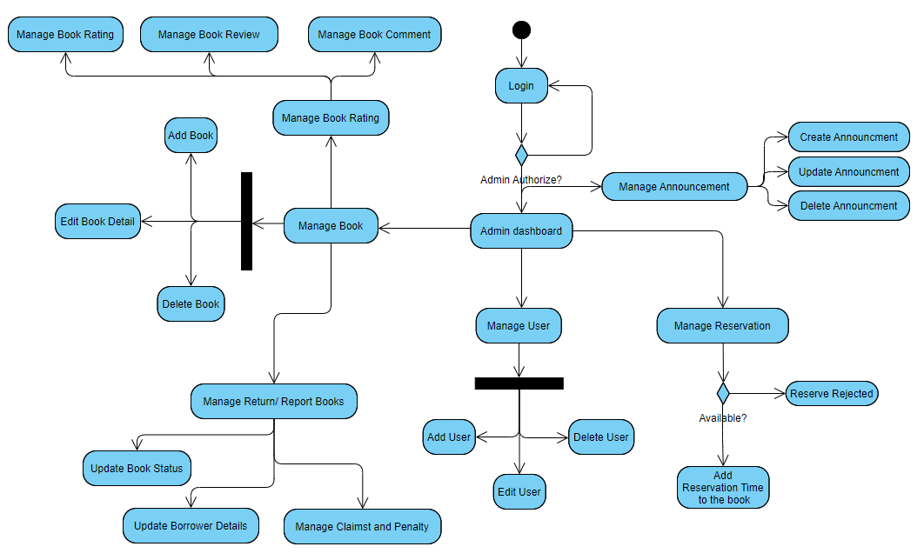

Figure 11: Administrator Activity Diagram

Figure 11 shows the activity diagram of the administrator. After the administrator logs in to the administrator terminal after verification, he can manage users, such as adding users, deleting users, and editing users. Administrators can manage bulletins, such as creating a new bulletin, updating bulletins, or deleting unused bulletins. Administrators can also manage book information, such as adding books, editing book information, and deleting books. Admins can also manage book ratings, where they can also manage and respond to book reviews. The administrator can manage the lost book report, and when there is a lost book, the administrator can review and reply to it. Administrators can manage borrowed book information, modify them, etc. Admins can manage book reservations and can review them.

## 4.3 Prototyping Interface

The client(mobile terminal) is a cross-platform App developed based on the Uni-app framework. The administrator side is developed based on the Vue.js language, and Element UI provides UI optimization. The backend is designed based on the Spring Boot framework developed by Pivotal.

**Client (mobile terminal)**

**Login & Register Dashboard**

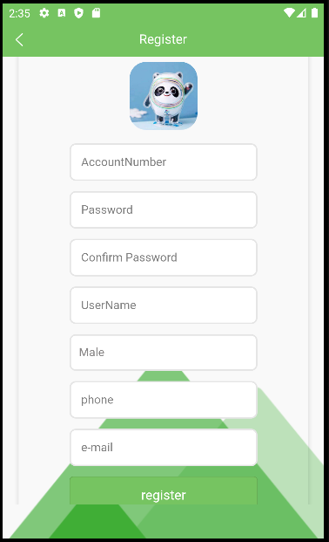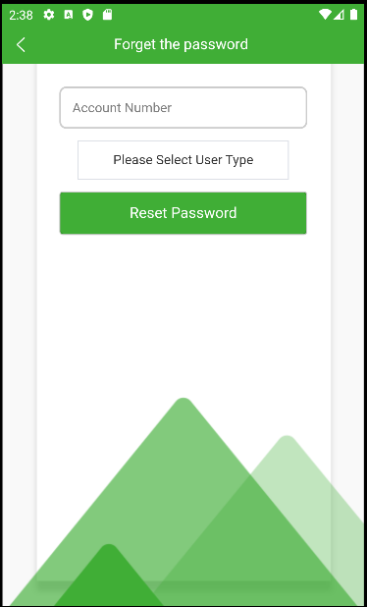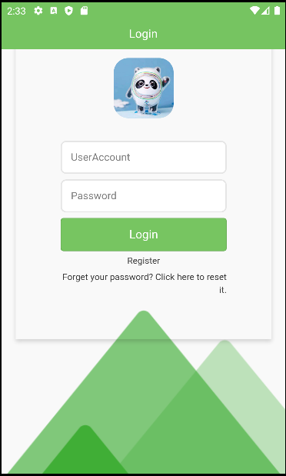

Figure 12: Login Page Figure 13: Register Page Figure 14: Forgot Password

The combination of three pages constructed the login & register section, which are Login Page, Register Page, and Forgot password page. The login page consists of a prominent login header above and a background image. Users who have obtained an account can log in to the system using their account number and password. Below the login button, there is a button called "Sign Up". This button redirects the user to the registration page and allows the user to register a new account.

On the registration page, new users need to enter their account number, username, phone number, email, and password. There is a text field provided to the user to double confirmed his password to avoid typo errors. If the user does not want to register a new account, he can press the back button in the upper left corner to go back to the login page or the back button at the bottom provided by the Android system.

On the Forgot Password page, if the user forgets the password he set, there is a text button that allows the user to reset his account password. The user needs to enter his account number and click reset password, the password will be reset to 123456.

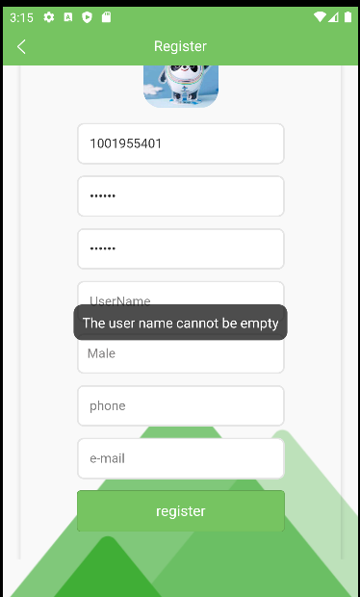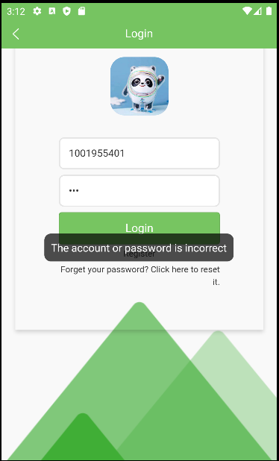

Figure 15: Login Error Handling Figure 16: Register Error Handling

According to Shneiderman's Eight Golden Rules, one specific rule is named "Providing Feedback". So it will work for the login and registration part. The login page and the registration page have error prompts, and these are validated by different rules. For example, in the login interface, if the password is entered incorrectly, when we still click the login button, it will prompt that the account password is wrong. In the registration interface, if you forget to fill in the required information, it will prompt you that the required information cannot be empty.

**Home Dashboard**

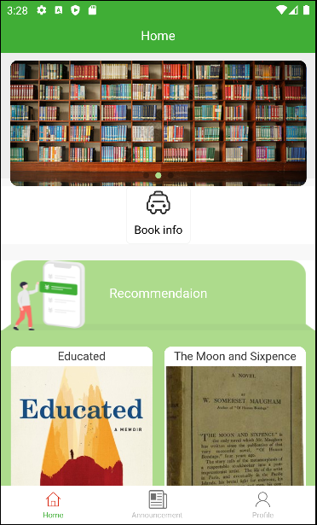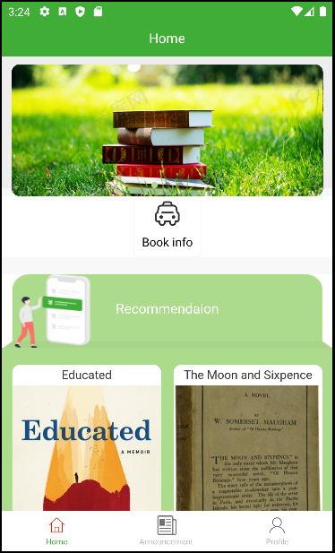

Figure 17: Home Dashboard Figure 18: Carousel Slider Effect

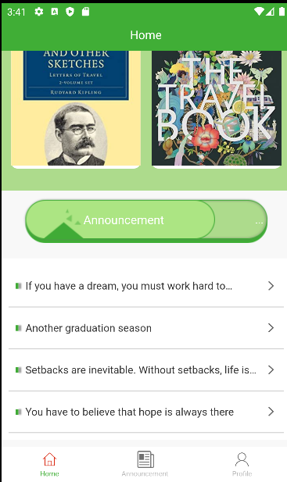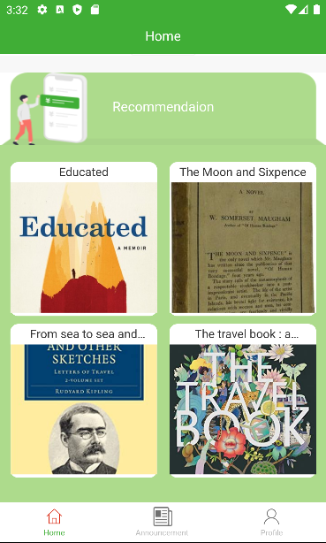In the home dashboard, we can see the book information button. Clicking the book information button will jump to the book information interface. At the top are three carousels that rotate as the background.

Figure 19: Recommended modules Figure 20: Announcement module

Further down is the book recommendation module, which recommends books based on the number of clicks on books. Clicking on a recommended book will jump to the book's details page. Further down is the announcement module. Clicking on the announcement will jump to the announcement page, where you can view the specific content of the announcement. At the bottom are three buttons, Home, Announcements, and Profile. Clicking the button will jump to the corresponding interface.

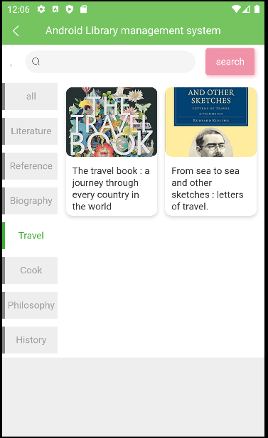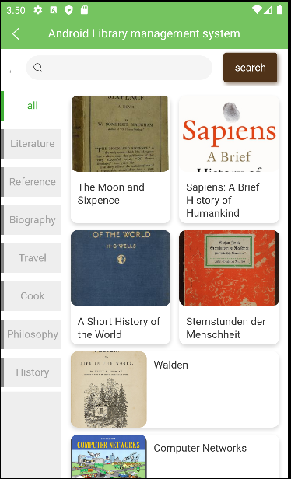**Book Information Section**

Figure 21: Book list Figure 22: Travel classified books

Clicking the Book Information button will take us to a page with all the book information. Here we can choose the books we want by category. Clicking a specific category will jump to the clicked category page. . For example, click on travel books, as shown in Figure 22: Travel classified books. We can also search for books by searching their names.

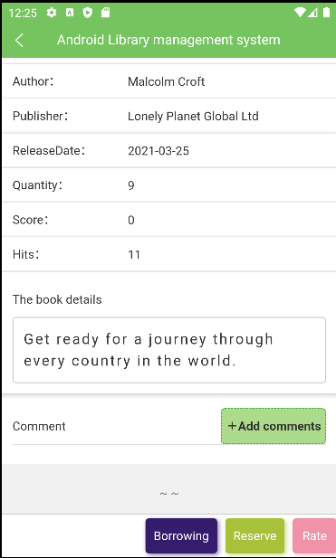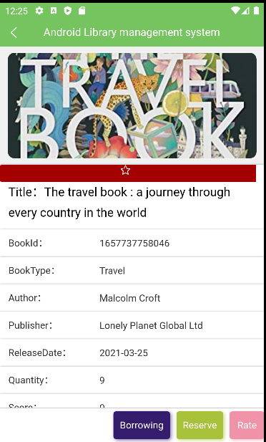Figure 23: Book Information Page(up) Figure 24: Book Information Page(down)

When we click on the book we want, we will see the details of the book. We can see the ID of the book, book type, author, publisher, publication time, quantity, rating and hits, etc. A brief introduction to the book is also displayed. There are three buttons at the bottom right of the page, Borrowing, Reserve, Rate. Click on them to borrow, book, rate, etc. We can also clearly see that there is a book review button in this interface. We can click on it to comment. We can also click the five-pointed star

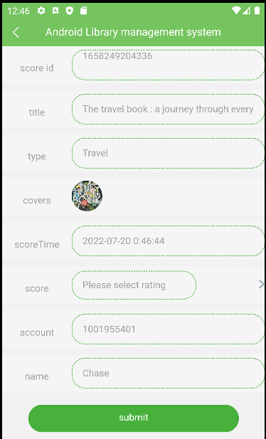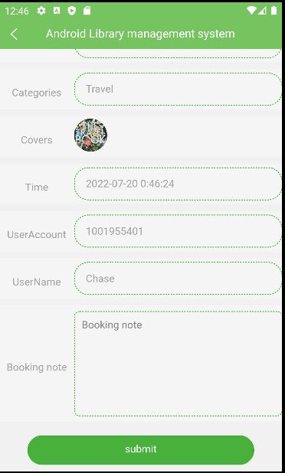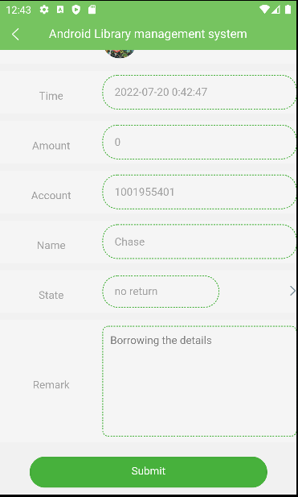button to collect books.

Figure 25: Book Borrowing Page Figure 26: Book reservation Page Figure 27: Book Rating Page

On the book borrowing page, we see that it will generate a Borrowing ID, record the borrowing time, and record the borrowing account number and name. And we can leave a borrowing note. Click the submit button, and this information will be submitted to the administrator.

On the book reservation page, a Reserve ID will be generated. Then the user account number, name, reservation time and other information will be submitted. We can write reservation remarks if needed.

In the book rating interface, we see that relevant information about the user will be submitted. Books are graded on a scale of 1 to 9, and we can choose the appropriate score for submission.

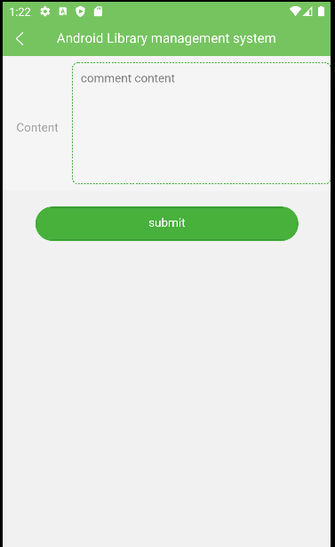**Book review page**

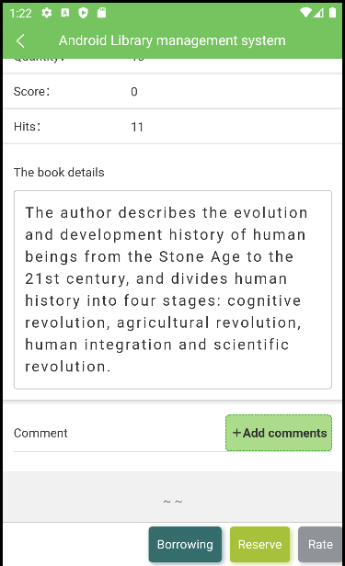Figure 28: Add book review page Figure 29: Fill out the comment page

Click the Add comments button to jump to the Figure 29 page. Here we can write down our thoughts on the book, etc., or report to the librarian about the situation of the book, such as damage, missing pages, etc. There can also be feedback from management about the library.

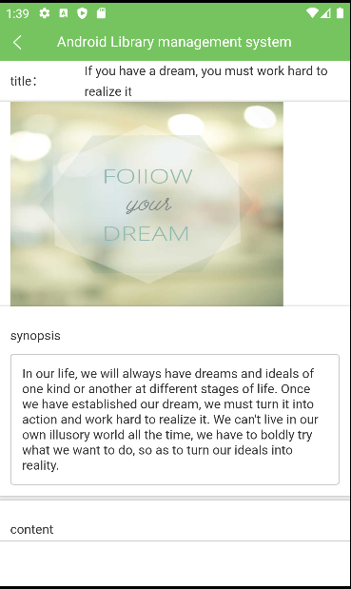**Announcement Section**

Figure 30: Announcement main page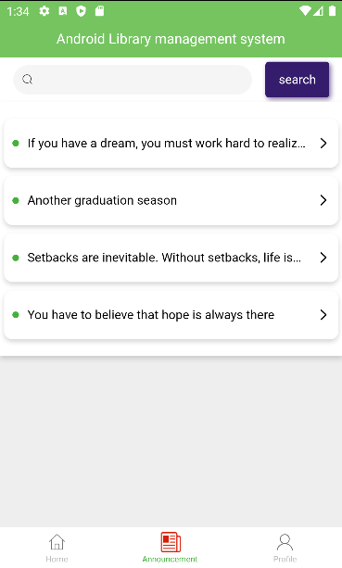 Figure 31: Announcement in detail

In the Announcements section, we can see announcements made by librarians. If there are many announcements, we can also search for the topic we are looking for in the search bar.

When we click on an announcement, we can see its details. There are pictures, introductions and details of the announcements. We can get relevant information about the library here.

**Profile Section**

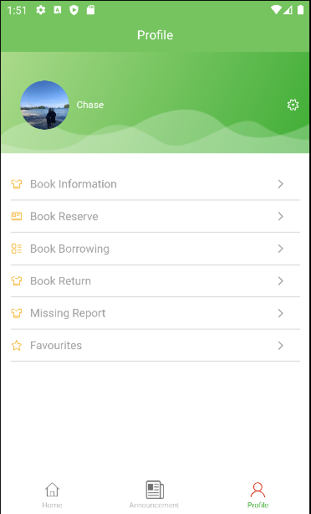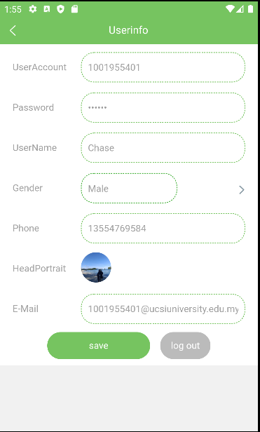

Figure 32: Profile Dashboard Figure 33: Settings Page

On the Profile page. We can see the user's book reservation, book borrowing, book return, book lost report and collection of books. Click the relevant button to view the user's book reservation, book loan, book return, book loss and book collection.

On the user settings page, we can modify the user password, name, gender, mobile phone number, avatar and email address. And you can log out from this interface.

**Administrator side(web)**

**Admin login page**

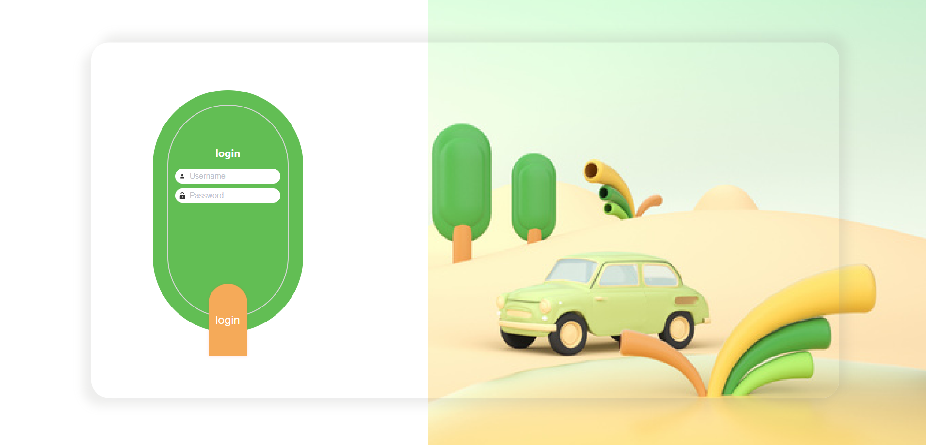

Figure 34: Administrator login interface

On this page, librarians enter their account name and password to log in.

**Home Page**

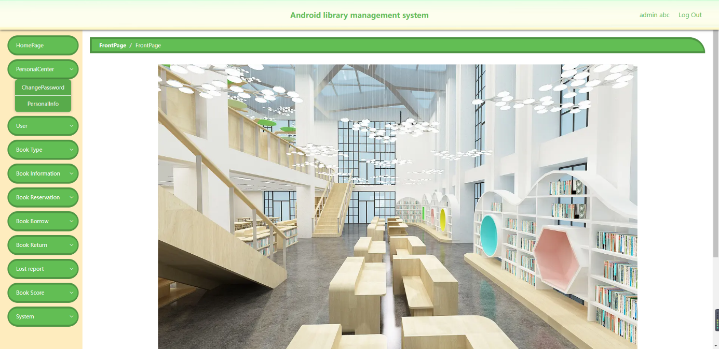

Figure 35: Home Page

On this page, we can see buttons such as Personal Center, User, Book Type, Book Information, Book Reservation, Book Borrowing, Book Return, Book Lost, Book Rating and Announcement Management. In the upper right corner is the logout system button. Can log out of account.

**Personal Center Section**

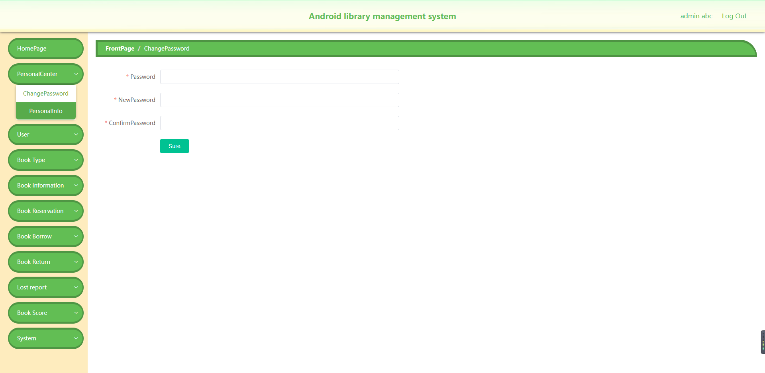

Figure 36: Administrator change password page

In this interface, if the administrator needs to modify his original password, he can fill in the original password first, and then fill in the new password twice. The reason for filling in the new password twice is to prevent the administrator from entering the wrong new password and forgetting the new password.

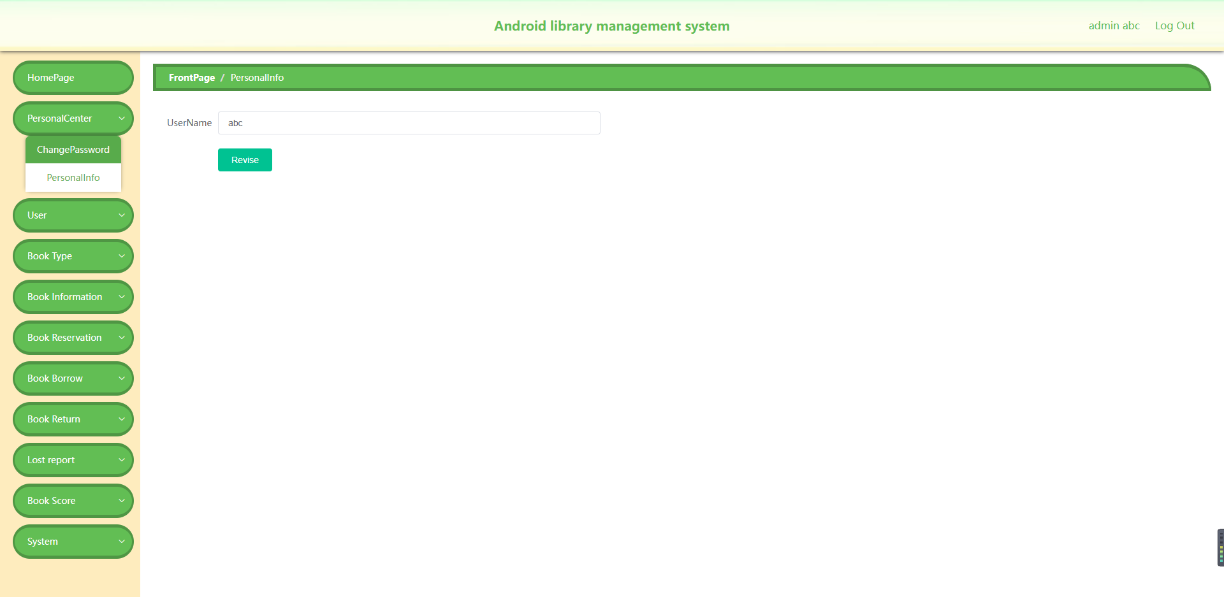

Figure 37: Admin change name page

If the administrator does not like his name, he can modify it on this page.

**User Information Section**

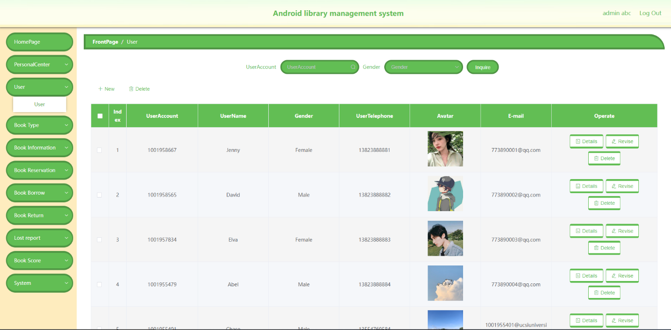

Figure 38: User Information page

On this page, administrators can modify the relevant information of registered users. Such as account number, user name, phone number, avatar, user account password, gender and email address. You can also add and delete user accounts. At the top of the page, you can search for users by user ID and gender.

**Book Type section**

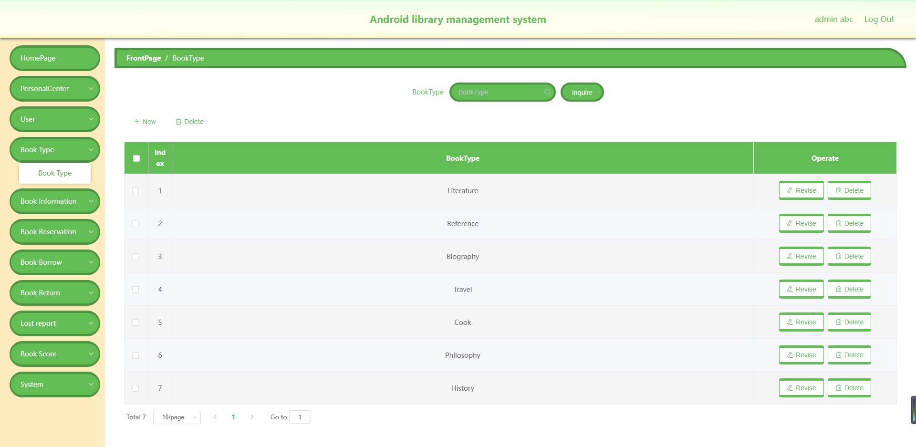

Figure 39: Book Type page

On this page, administrators can add and delete book types, as well as modify existing book types. There is a book type search at the top, through which administrators can search for the book category they want to query.

**Book Information section**

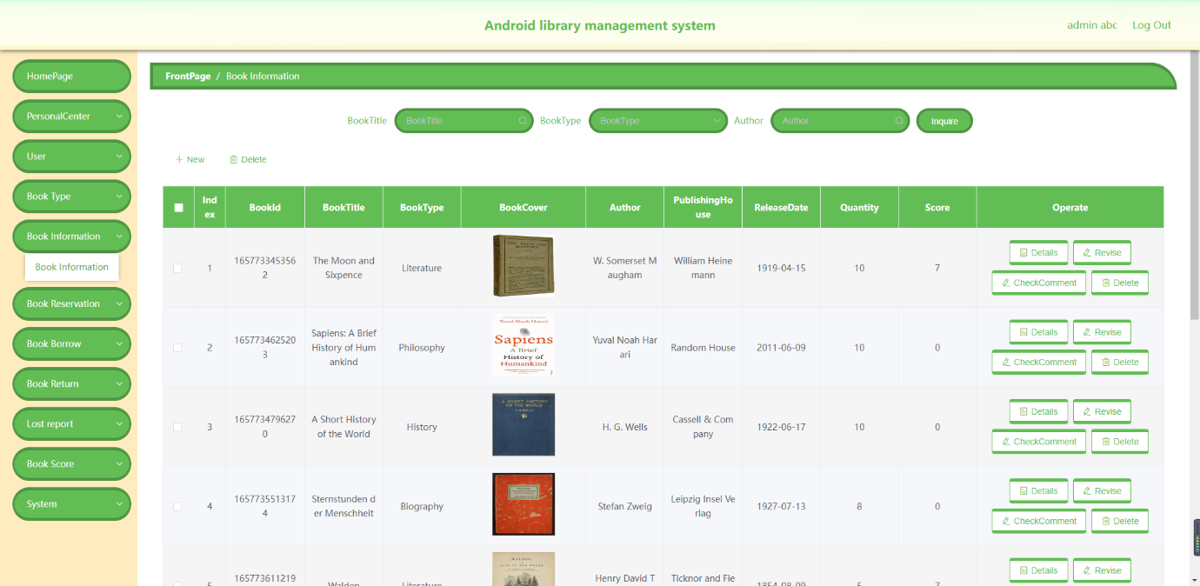

Figure 40: Book Information page

On this page administrators can add and delete books in the system. The information from existing books can be modified. At the top, you can search for books based on book name, book type and author. Admins can view and reply to comments on each book. In the face of inappropriate comments, admins can delete them.

**Book Reservation section**

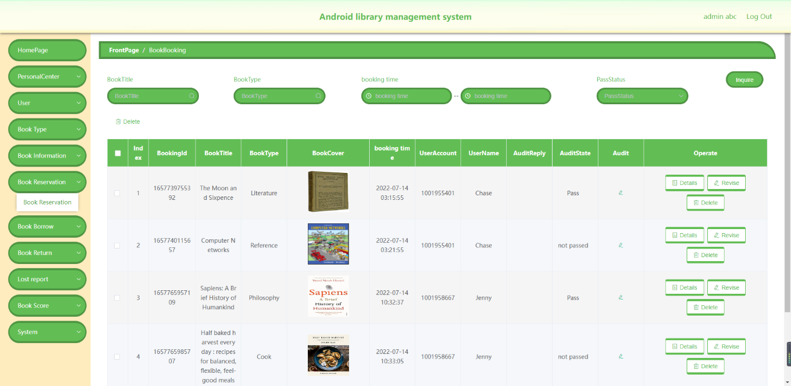

Figure 41: Book Reservation page

On this page, administrators can manage book reservations. For example, view review booking information. At the top of the page, you can query reservation information by book name, book type, reservation time and review status.

**Book Borrowing Section**

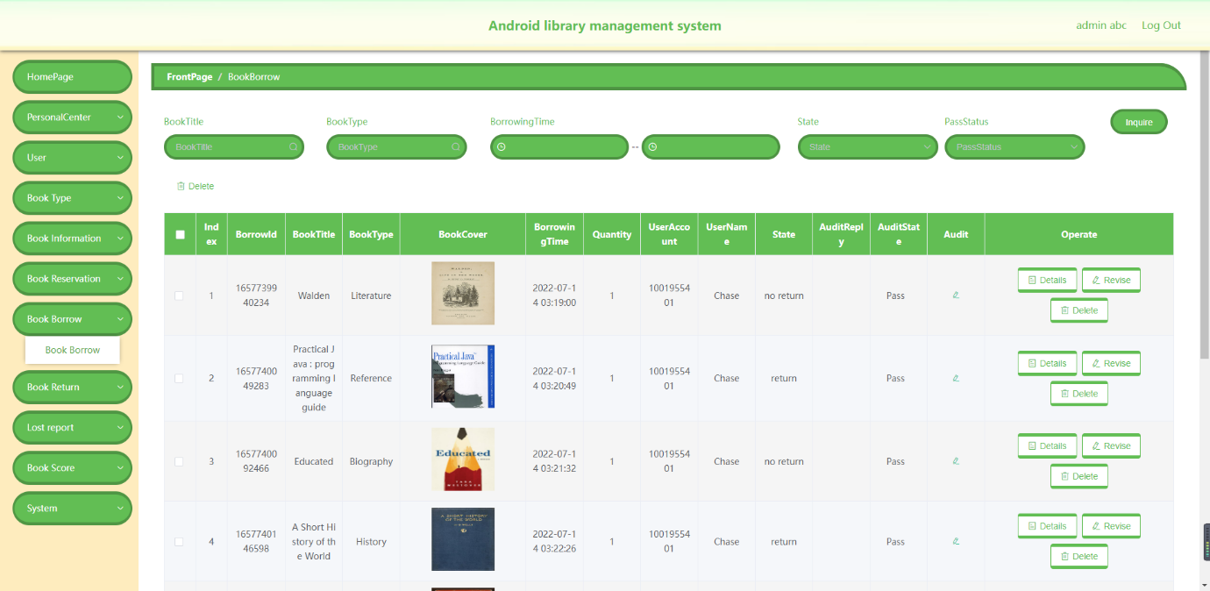

Figure 42: Book Borrowing page

On this page, administrators can review applications for book borrowing. You can also modify the return status of the book. The administrator has the right to refuse the application for book loan. Administrators can query related user borrowing information through book name, book type, borrowing time and review status.

**Book Return section**

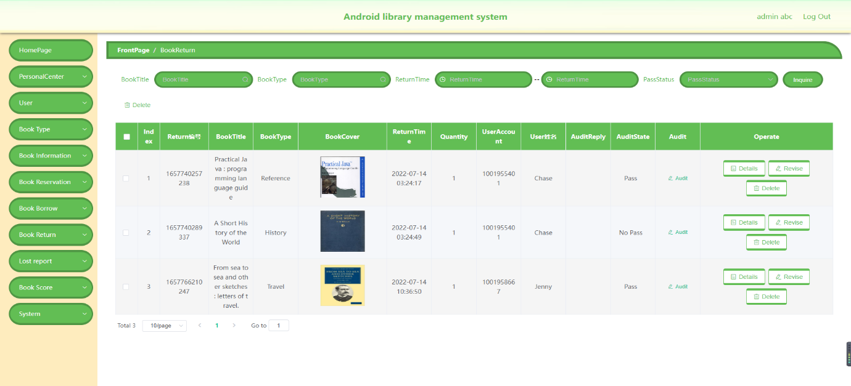

Figure 42: Book Return page

On this page, administrators can review the application for book returns. And can search and modify the user's book return information.

**Lost report section**

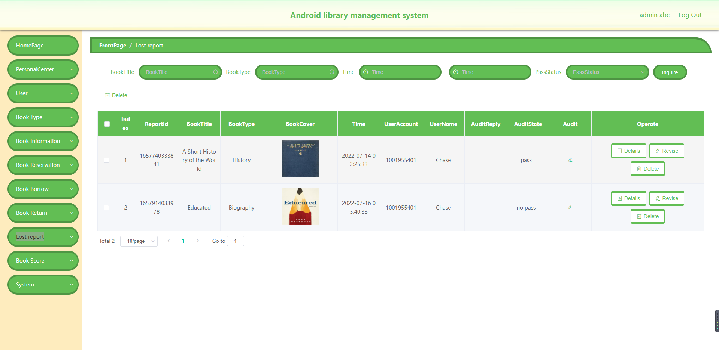

Figure 43: Lost report page

The administrator manages the lost user report through this page. Administrators can modify and delete missing information. Through the button above, administrators can search for missing report information.

**Book Score section**

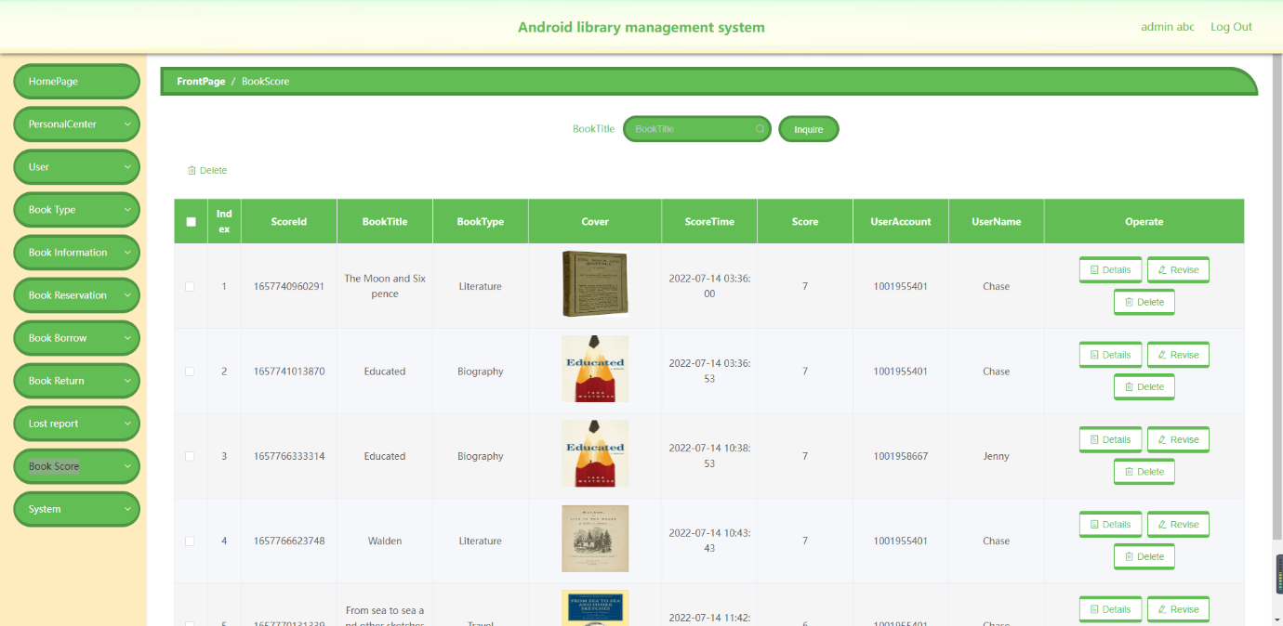

Figure 44: Book Score page

This page displays information about all users' ratings of books. Administrators can modify this information. Administrators can search rating information by book name.

**Carousel section**

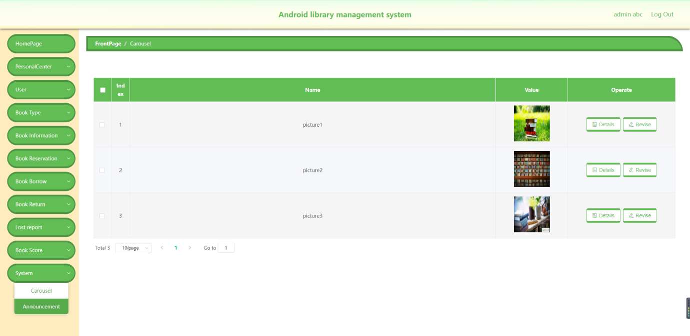

Figure 45: carousel page

Administrators can manage and modify the client carousel on this page.

**Announcement section**

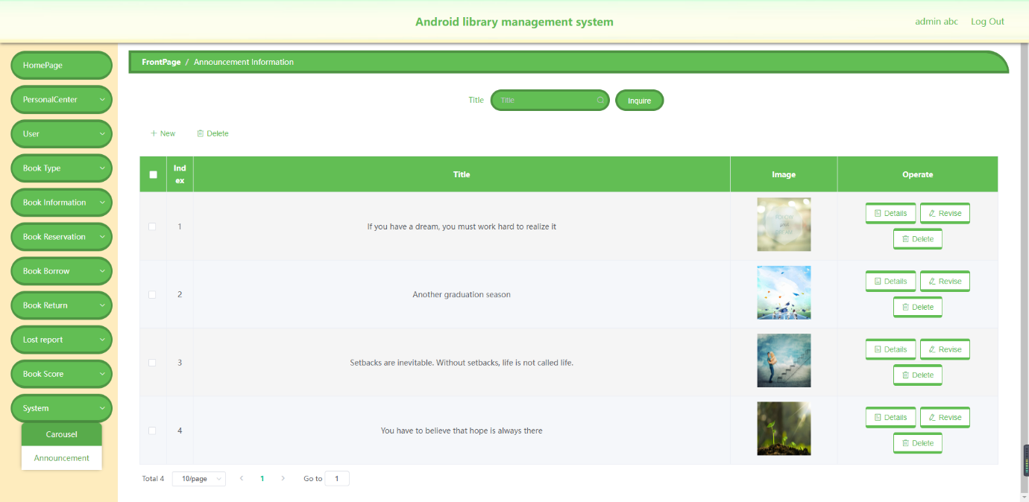

Figure 46: Announcement page

On this page administrators can post announcements and modify original announcements. You can search by announcement title at the top.

## 4.4 Featured Code

**Book Review Module**

1. The front-end triggers onCommentTap to go to the add book comment page, and transmit the id of the book to the add data page

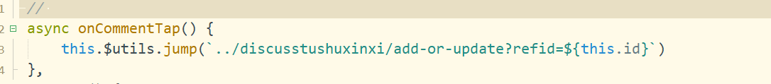

2. The front-end add-or-update page first determines whether the user is logged in when the onload function loads, and then receives the book id sent by the previous page to determine which book to add

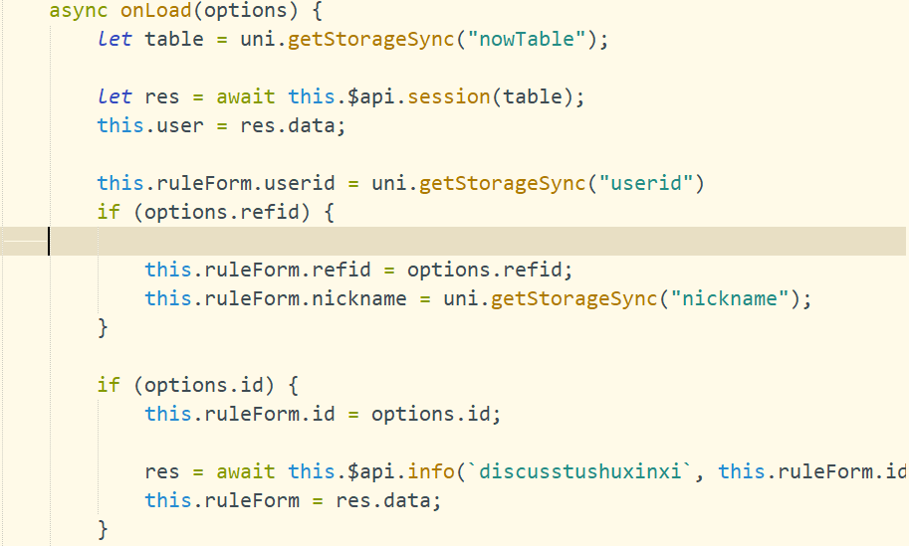

3. Request to add method

The front end here is a DiscusstushuxinxiEntity type, so the DiscusstushuxinxiEntity type is used directly to accept parameters, but the id of the DiscusstushuxinxiEntity type is not set, so we set an id here.

Id generation rules

According to the current time in milliseconds + the random number generated by the Math.floor(Math.random()*1000) method.

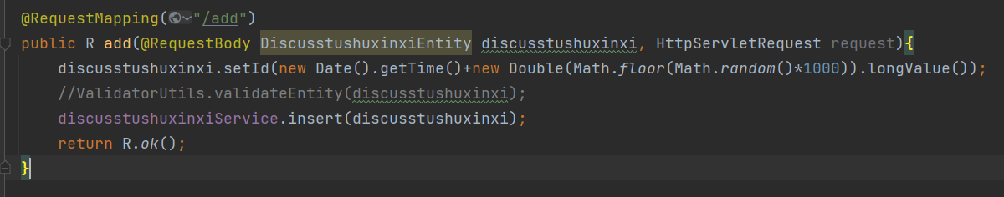

4. The front-end book review display method, when the book information page is loaded, the id field of the book is obtained and a request carrying the book id field is sent. Request data and return it to the front end.

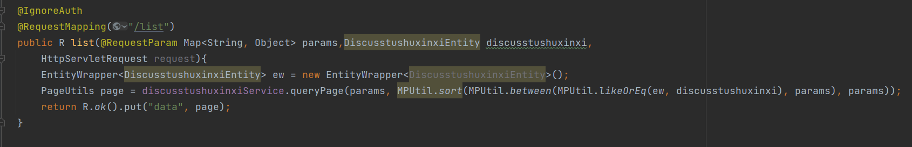

**Book Scoring Module**

The front-end triggers the onAcrossTap method to store the book information in the cache and jumps to the book rating page.

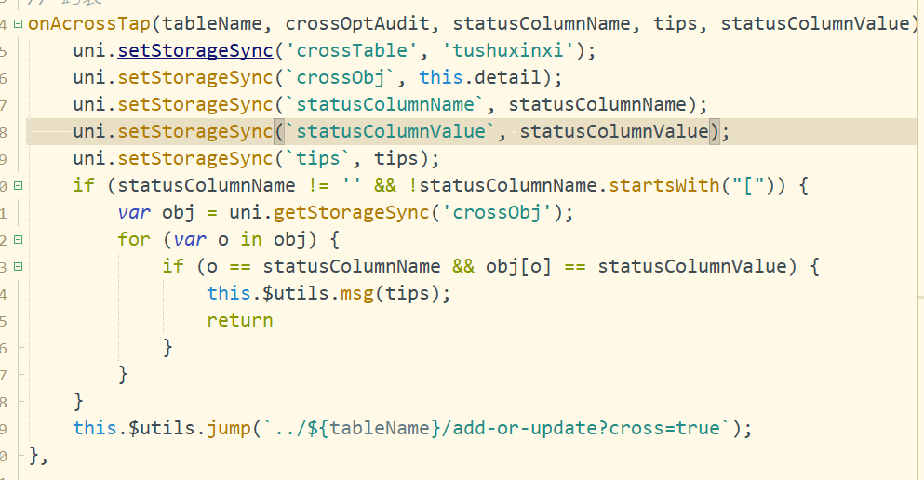

**Add a rating**

Then add the scoring information to the database, and pass in the TushupingfenEntity type parameter brought by the front end.

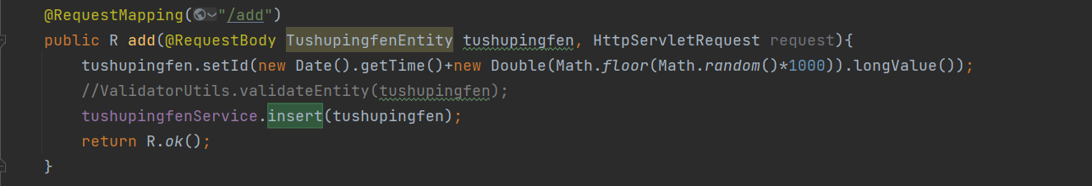

**Delete scores in batches in the background**

The front end passes the id to be deleted as an array of Long type, and the Arrays.asList() method converts the array into a collection. After calling, the deleteBatchIds method provided by Mybatis-Plus performs batch deletion.

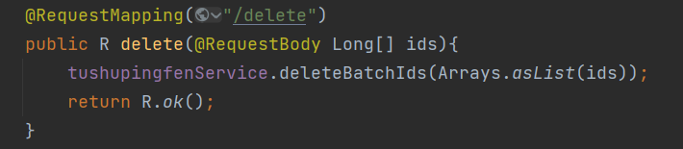

**Score calculation**

Query how many people rated the book, then calculate the sum of all the ratings, and divide the sum of ratings by the number of ratings to get the book's rating

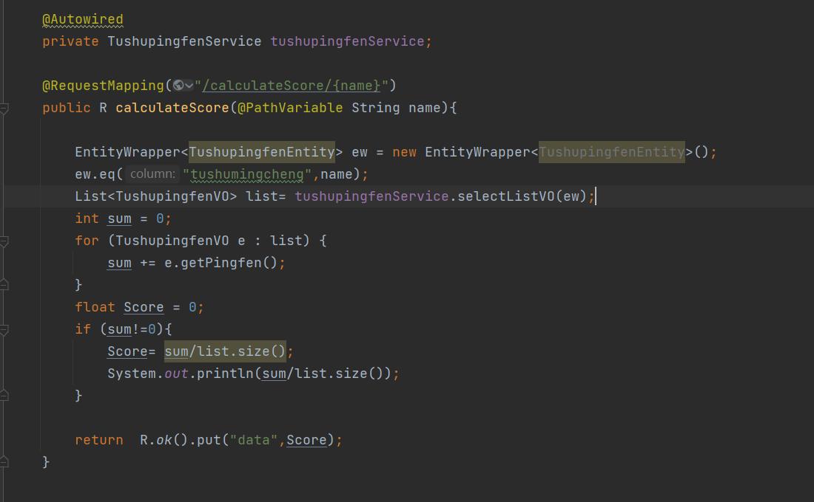

**Book Borrowing Module**

**Book query**

Jieyueshijianstart is the borrowing start time

Jieyueshijianend is the loan end time

Here, it is judged whether these two parameters are empty. If the part is not empty, it is queried according to these two time points.

Params are the rest of the query conditions.

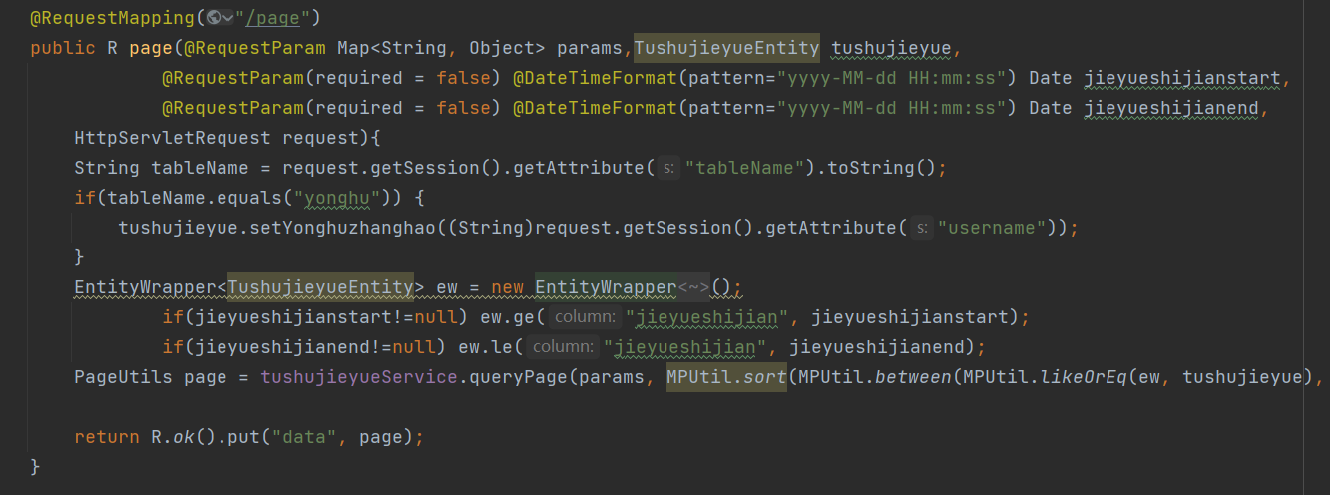

**View details**

According to the borrowing id passed by the front-end request, it is judged which record is, and then the query returns the value.

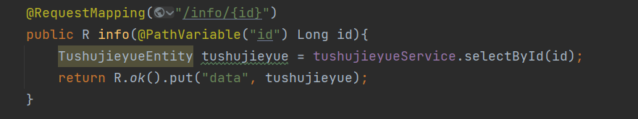

**Audit and reply**

Click the audit button, and the audit pop-up window will pop up. After clicking confirm, execute then to initiate a request to call the modification interface. The parameter shform is the parameter entered in the audit pop-up window. After the modification is successful, the operation in then is executed to prompt that the operation is successful, and the page is refreshed.

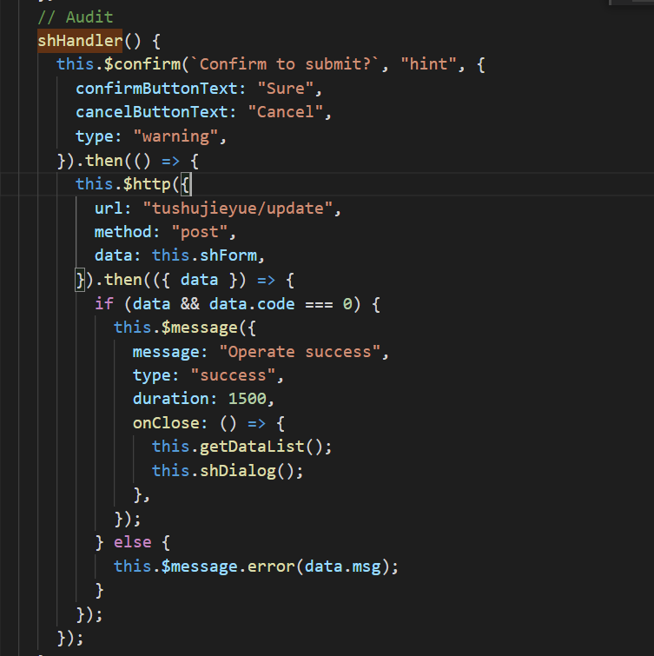

# CHAPTER 5: EVALUATION

## 5.1 Chapter Introduction

The purpose of this chapter is to evaluate the work done to complete this project. And find out if the app was developed correctly and meets the goals of this project. In addition, this evaluation process is also important for the limitations of the developed application and areas for improvement. In Section 5.1 System tests and test cases, include all necessary tests to ensure the quality of the developed application. In addition, this chapter includes Performance Evaluation & User Experience Survey (in Section 5.2).

## System Testing & Test Cases

One of the crucial steps in the implementation and development phases is testing, which is used to determine whether a component, subsystem, or system has been designed appropriately and to look for flaws. System tests have been carried out to remove application bugs. The planning, development, and execution of test cases for each interface constitute the first step in the testing process. The following sections, organized by module, provide a summary of test case IDs 1 through 16 and test results.

**5.2.1 Test Case for Authentication**

The following test case ID 1 is used to test the authentication function of users and administrators. All test scenarios in Test Case ID 1 passed.

|  |  |  |  |  |
| --- | --- | --- | --- | --- |
| Test Case ID: 1 | | | | |
| Test Case Description:  (a) Make sure that the user login, register, forget password functions are working properly.  (b) Make sure the librarian login is functional. | | | | |
| Module/Interface: Authentication Interface | | | | |
| **No #** | **Item** | **Test Scenario** | **Expected Result** | **Test Status** |
| 1 | Login (mobile terminal) | Enter the account number of an existing user, enter the password set by the user, and click the Login button. | The system submits the account number and password to the database for verification. The user will be successfully logged into the application after the authentication is successful. | Pass |
| 2 | Register (mobile terminal) | The user enters their account number, username, phone number, email and password and clicks the register button. | The system submits data such as account number, user name, phone number, email and password to the database for verification, so that the user can register an account and keep data records in the database. After the information is entered completely, the system will prompt that the registration is successful. | Pass |
| 3 | Forget password(mobile terminal) | On the web management side, enter the administrator account and password. | The account number is submitted to the database, and the password will be reset to the initial password 123456. | Pass |
| 4 | Login(librarian side) | Select the employee's status (normal/deactivated) and click the Search button to view the details of the employee with the corresponding status | The system submits the account and password to the database for verification. After successful authentication, the user will successfully log into the application. | Pass |

**5.2.2 Test Case for User borrows books**

The following test case ID 2 is used to test the user book borrow functionality. All test scenarios in Test Case ID 2 passed.

|  |  |  |  |  |
| --- | --- | --- | --- | --- |
| Test Case ID: 2 | | | | |
| Test Case Description:  (a) Ensure that users can accurately enter the borrowing book interface according to the setting button.  (b) Make sure that the function of users modifying the time of borrowing books works properly.  (c) Make sure that the function for users to fill in notes for borrowed books works properly. | | | | |
| Module/Interface: User borrowing interface | | | | |
| **No #** | **Item** | **Test Scenario** | **Expected Result** | **Test Status** |
| 1 | Borrowing | Click on the desired book and click the Borrow button. | The interface jumps to the borrowing details page of the book. | Pass |
| 2 | Time | Click the time text box to modify the book borrowing time. | The borrowing time of the book is modified successfully, and the borrowing time is saved to the database. | Pass |
| 3 | Remark | Click the remark text box and enter the book borrowing remarks. | The borrowing notes are submitted successfully, and the information is saved to the database. | Pass |

**5.2.3 Test Case for Book reservation**

The following test case ID 3 is used to test the user book reservation function. All test scenarios in Test Case ID 3 passed.

|  |  |  |  |  |
| --- | --- | --- | --- | --- |
| Test Case ID: 3 | | | | |
| Test Case Description:  (a) Make sure that the user can accurately enter the reservation book interface according to the setting button.  (b) Ensure that the functionality of the user to modify the scheduled book time is correct.  (c) Ensure that the function for users to fill in the reservation book remarks is normal. | | | | |
| Module/Interface: User book reservation interface | | | | |
| **No #** | **Item** | **Test Scenario** | **Expected Result** | **Test Status** |
| 1 | Reserve | Click on the desired book, then click the Reserve button. | The page jumps to the book reservation details interface. | Pass |
| 2 | Time | Click the time text box and enter the appointment time. | The reservation time of the book is modified successfully, and the reservation time is saved to the database. | Pass |
| 3 | Remark | Click in the Notes text box and enter a note for the book reservation. | The appointment note is submitted successfully, and the information is saved in the database. | Pass |

**5.2.4 Test Cases for Book rating**

The following test case ID 4 is used to test the user book rating function. All test scenarios in test case ID 4 passed.

|  |  |  |  |  |
| --- | --- | --- | --- | --- |
| Test Case ID: 4 | | | | |
| Test Case Description:  (a) Make sure that users can accurately enter the book rating interface according to the setting button.  (b) Make sure that the functionality for the user to modify the book rating time is correct.  (c) Make sure that the user select book rating feature is working properly. | | | | |
| Module/Interface: User book rating interface | | | | |
| **No #** | **Item** | **Test Scenario** | **Expected Result** | **Test Status** |
| 1 | Rate | Click the desired book, then click the Rate button. | The page will jump to the book rating details interface. | Pass |
| 2 | ScoreTime | Click the Time text box and modify the scoring time. | The scoring time is modified successfully, and the scoring time is saved in the database. | Pass |
| 3 | Score | Click the Score text box to select the score the user wants to give. | The book scoring submission is successful and the information is saved in the database. | Pass |

**5.2.5 Test cases for user Announcements**

The following test case ID 5 is used to test the announcement function. All test scenarios in test case ID 5 passed.

|  |  |  |  |  |
| --- | --- | --- | --- | --- |
| Test Case ID: 5 | | | | |
| Test Case Description:  (a) Make sure users can view announcements normally.  (b) Make sure that the announcement information can be retrieved according to the set filter conditions, and the results are returned to the interface for display. | | | | |
| Module/Interface: User Announcements interface | | | | |
| **No #** | **Item** | **Test Scenario** | **Expected Result** | **Test Status** |
| 1 | Announcement | Click the announcement button and click the detailed announcement to read. | Loads details for a specific announcement and displays it on the page. | Pass |
| 2 | Search | After entering the field data for any bulletin, click the Search button to check that all bulletin information under the filter is displayed. | The details of the announcement under the corresponding filter conditions are filtered from the database and displayed correctly and completely on this interface. | Pass |

**5.2.6 Test cases for user Home Dashboard**

The following test case ID 6 is used to test the User Dashboard functionality. All test scenarios in test case ID 6 passed.

|  |  |  |  |  |
| --- | --- | --- | --- | --- |
| Test Case ID: 6 | | | | |
| Test Case Description:  (a) Make sure the Dashboard's recommended books are functional.  (b) Make sure the Dashboard's announcements are functional.  (c) Make sure the Dashboard's book entry is functional. | | | | |
| Module/Interface: Home Dashboard Interface | | | | |
| **No #** | **Item** | **Test Scenario** | **Expected Result** | **Test Status** |
| 1 | Home | Click the Home button | The page will jump to the Home interface, which will allow users to navigate to different functions and pages. | Pass |
| 2 | Carousel | Swipe the carousel to see different pictures placed by the admin. | Swipe successfully | Pass |
| 3 | Book info | Click this button. | The page will navigate to all book information pages. | Pass |
| 4 | Recommendation | Click on Books in Recommended Books | The page will navigate to the detailed information page of the book, where users can borrow, reserve, and grade the book. | Pass |
| 5 | Announcement | Click for announcement information | The page will jump to the announcement details page. | Pass |

**5.2.7 Test cases for user Book Information List**

The following test case ID 7 is used to test the user book information page functionality. All test scenarios in test case ID 7 passed.

|  |  |  |  |  |
| --- | --- | --- | --- | --- |
| Test Case ID: 7 | | | | |
| Test Case Description:  (a) Ensure that book information can be retrieved according to the set filter conditions, and the results are returned to the interface for display  (b) Make sure the functionality of each book category information works well | | | | |
| Module/Interface: User Book Information List Interface | | | | |
| **No #** | **Item** | **Test Scenario** | **Expected Result** | **Test Status** |
| 1 | Search | After entering the field data for any book title, click the "Search" button to check that all address information under the filter is displayed | The details of the books under the corresponding filter conditions are filtered from the database and displayed correctly and completely on this interface | Pass |
| 2 | Literature | Click the category button to filter the database | The database filters out literature books and displays them correctly on this interface | Pass |
| 3 | Reference | Click the category button to filter the database | The database filters out Reference books and displays them correctly on this interface | Pass |
| 4 | Biography | Click the category button to filter the database | The database filters out Biography books and displays them correctly on this interface | Pass |
| 5 | Travel | Click the category button to filter the database | The database filters out Travel books and displays them correctly on this interface | Pass |
| 6 | Cook | Click the category button to filter the database | The database filters out Cook books and displays them correctly on this interface | Pass |
| 7 | Philosophy | Click the category button to filter the database | The database filters out Philosophy books and displays them correctly on this interface | Pass |
| 8 | History | Click the category button to filter the database | The database filters out History books and displays them correctly on this interface | Pass |
| 9 | All | Click the category button to filter the database | The database filters out all books and displays them correctly on this interface | Pass |

**5.2.8 Test cases for user profile**

The following test case ID 8 is used to test the functionality of the user profile page. All test scenarios in test case ID 8 passed.

|  |  |  |  |  |
| --- | --- | --- | --- | --- |
| Test Case ID: 8 | | | | |
| Test Case Description:  (a) Make sure that viewing book reservations works well  (b) Make sure the feature to check book borrowing works well  (c) Make sure that the function to check the return of your book is working well  (d) Make sure that viewing missing books works well  (e) Make sure that viewing your favorites works well  (f) Make sure the functionality to modify user information works well  (g) Make sure that the function to enter the book list works well | | | | |
| Module/Interface: User profile Interface | | | | |
| **No #** | **Item** | **Test Scenario** | **Expected Result** | **Test Status** |
| 1 | Book Information | Clicking this button page will navigate to the book list page | Page navigation succeeded | Pass |
| 2 | Book Reserve | Click this button, the page will navigate to the user's reservation book information interface. | On the reservation book information interface, users can view the reserved books, and click the reserved books to see the detailed information of the reserved books. | Pass |
| 3 | Book Borrowing | Clicking this button, the page will navigate to the user's book borrowing information interface. Click on Borrowed Books | Display the borrowed books of the user, click on the borrowed books to view the relevant information of this book | Pass |
| 4 | Book Return | Clicking this button, the page will navigate to the user's book return information interface. | Display the returned books of the user, click the returned book to view the related information of this book | Pass |
| 5 | Missing Report | Clicking this button, the page will navigate to the user's Loss Report Information screen. | Display the lost report book of the user, click the book that has been reported lost to view the relevant information of the book | Pass |
| 6 | Favorites | Clicking this button, the page will navigate to the user's book collection interface. | Display the user's favorite books, click the favorite book to view the related information of the book | Pass |
| 7 | User Settings | Click this button to enter this page to modify user information, such as password, username, gender, phone number, email, avatar and other information. This page can also log out of the system. | The user information is modified successfully, and the logout of the system is successful. | Pass |

**5.2.9 Test cases for User Management**

The following test case ID 9 is used to test the functionality of the user management page. All test scenarios in test case ID 9 passed.

|  |  |  |  |  |
| --- | --- | --- | --- | --- |
| Test Case ID: 9 | | | | |
| Test Case Description:  (a) Ensure that user information can be retrieved according to the set filter criteria, and the results are returned to the interface for display  (b) Make sure adding user info works well  (c) Make sure the functionality to modify user information works well  (d) Make sure that the functionality to delete user information works well | | | | |
| Module/Interface: User Management Interface | | | | |
| **No #** | **Item** | **Test Scenario** | **Expected Result** | **Test Status** |
| 1 | User Account | Enter the account number of an existing user and click the search button to view the details of the employees in the corresponding department | Filter the details of the corresponding user account from the database and display it correctly and completely on the interface | Pass |
| 2 | Gender | Enter the gender of the user and click the search button to view the details of the user in that gender | Filter the user information of the corresponding gender from the database and display it correctly and completely on the interface | Pass |
| 3 | Delete | Delete the user's account from the system, then check the interface and database (if the user's account information has been deleted) | All information about users has been removed from the database and interface | Pass |
| 4 | New | Add the user's account in the system, then check the interface and database (if the user's account information has been added) | All information about users has been added in database and interface | Pass |
| 5 | Revise | Modify the user's account information, including the employee's username, account number, phone number, email address, gender, password, and avatar | All information of the user has been modified in the database and interface | Pass |

**5.2.10 Test cases for Book Type Management**

The following test case ID 10 is used to test the functionality of the book type management page. All test scenarios in test case ID 10 passed.

|  |  |  |  |  |
| --- | --- | --- | --- | --- |
| Test Case ID: 10 | | | | |
| Test Case Description:  (a) Ensure that book type information can be retrieved according to the set filter conditions, and the results are returned to the interface for display  (b) Make sure adding book type information works well  (c) Make sure the functionality to modify book type information works well  (d) Make sure the functionality to remove book type information works well | | | | |
| Module/Interface: Book Type Management Interface | | | | |
| **No #** | **Item** | **Test Scenario** | **Expected Result** | **Test Status** |
| 1 | Book Type | Enter an existing book type and click the search button to view details for that book type | Filter the corresponding book type details from the database and display them correctly and completely on the interface | Pass |
| 2 | Delete | Remove the book type from the system, then check the interface and database (if the book type has been removed) | All information about book types has been removed from the database and interface | Pass |
| 3 | New | Add the book type in the system, then check the interface and database (if the book type has been added) | All information about book types has been added to the database and interface | Pass |
| 4 | Revise | Edit the name of a book type | All information for book types has been modified in the database and interface | Pass |

**5.2.11 Test cases for Book Information Management**

The following test case ID 11 is used to test the functionality of the book information management page. All test scenarios in test case ID 11 passed.

|  |  |  |  |  |
| --- | --- | --- | --- | --- |
| Test Case ID: 11 | | | | |
| Test Case Description:  (a) Ensure that book information can be retrieved according to the set filter conditions, and the results are returned to the interface for display  (b) Make sure adding book information works well  (c) Make sure the functionality to modify book information works well  (d) Make sure that the functionality to delete book information works well  (e) Make sure the ability to view responses to book reviews works well | | | | |
| Module/Interface: Book Information Management Interface | | | | |
| **No #** | **Item** | **Test Scenario** | **Expected Result** | **Test Status** |
| 1 | Book Title | Enter an existing book title and click the search button to view details for that book | Filter the corresponding book details from the database and display them correctly and completely on the interface | Pass |
| 2 | Book Type | Enter the type of book and click the search button to view details for that type of book | Filter the corresponding book category information from the database and display it correctly and completely on the interface | Pass |
| 3 | Delete | Delete the book from the system, then check the interface and database (if the book has been deleted) | All information about the book has been removed from the database and interface | Pass |
| 4 | New | Add book information in the system, then check the interface and database (if book information has been added) | All information about the book has been added to the database and interface | Pass |
| 5 | Revise | Modify book information, including book name, genre, cover, author, publisher, publication date, rating, and introduction. | All information of the book has been modified in the database and interface | Pass |
| 6 | Author | Enter an author's name and click the search button to view all books by that author | Filter the corresponding author information from the database and display it correctly and completely on the interface | Pass |
| 7 | Check Comment | View and reply to book reviews, or delete book reviews | All information for this review has been modified in the database and interface | Pass |

**5.2.12 Test cases for Book reservation management**

The following test case ID 12 is used to test the functionality of the book reservation management page. All test scenarios in test case ID 12 passed.

|  |  |  |  |  |
| --- | --- | --- | --- | --- |
| Test Case ID: 12 | | | | |
| Test Case Description:  (a) Ensure that book reservation information can be retrieved according to the set filter conditions, and the results are returned to the interface for display  (b) Make sure the ability to modify book reservations works well  (c) Make sure the ability to delete book reservations works well | | | | |
| Module/Interface: Book reservation management Interface | | | | |
| **No #** | **Item** | **Test Scenario** | **Expected Result** | **Test Status** |
| 1 | Book Title | Enter an existing book title and click the search button to view reservations for that book | Filter the corresponding appointment information from the database and display it correctly and completely on the interface | Pass |
| 2 | Book Type | Enter a book type and click the search button to view reservations for that book type | Filter the corresponding book reservation information from the database and display it correctly and completely on the interface | Pass |
| 3 | Delete | Delete the reservation book from the system, then check the interface and database (if the reservation book has been deleted) | All information about this reservation book has been removed from the database and interface | Pass |
| 4 | Booking time | Enter an appointment time and click the search button to view books for that appointment time | Filter the corresponding reservation time information from the database and display it correctly and completely on the interface | Pass |
| 5 | Revise | Modify book reservation information, including book name, genre, cover, reservation time, reservation account number, reservation name | The appointment information has been modified in the database and interface | Pass |
| 7 | Pass Status | Select a book pass status and click the search button to view pre-order information for that status | Filter the corresponding booking status from the database and display it correctly and completely on the interface | Pass |
| 8 | Audit | Select the review status of the book | All status information about this reservation will be displayed in all interfaces | Pass |

**5.2.13 Test cases for Book Borrowing Management**

The following test case ID 13 is used to test the functionality of the book lending management page. All test scenarios in test case ID 13 passed.

|  |  |  |  |  |
| --- | --- | --- | --- | --- |
| Test Case ID: 13 | | | | |
| Test Case Description:  (a) Ensure that book borrowing information can be retrieved according to the set filter conditions, and return the results to the interface for display  (b) Make sure the functionality to modify borrowed books works well  (c) Make sure that the feature to delete borrowed book information works well | | | | |
| Module/Interface: Book Borrowing management Interface | | | | |
| **No #** | **Item** | **Test Scenario** | **Expected Result** | **Test Status** |
| 1 | Book Title | Enter the title of the borrowed book and click the search button to view the borrowed book information | Filter the corresponding borrowing information from the database and display it correctly and completely on the interface | Pass |
| 2 | Book Type | Enter a book type and click the search button to see borrowings for that book type | Filter the corresponding borrowing information from the database and display it correctly and completely on the interface | Pass |
| 3 | Delete | Delete the borrowed book from the system, then check the interface and database (if the borrowed book has been deleted) | All information about this borrowed book has been removed from the database and interface | Pass |
| 4 | Borrowing time | Enter a borrowing time and click the search button to view books for that borrowing time | Filter the corresponding borrowing time information from the database and display it correctly and completely on the interface | Pass |
| 5 | Revise | Modify borrowing information, including booking name, type, cover, borrowing time, booking account number, booking name, quantity, and return status | Modified borrowing information in the database and interface | Pass |
| 7 | Pass Status | Select a book pass status and click the search button to view borrowing information for that status | Filter the corresponding borrowing status from the database and display it correctly and completely on the interface | Pass |
| 8 | Audit | Select the review status of the book | All status information about this borrowing will be displayed in all interfaces | Pass |
| 9 | Status | Select the book return status and click the search button to view borrowing information for that status | Filter the corresponding borrowing status from the database and display it correctly and completely on the interface | Pass |

**5.2.14 Test cases for Book Return Management**

The following test case ID 14 is used to test the functionality of the book return management page. All test scenarios in test case ID 14 passed.

|  |  |  |  |  |
| --- | --- | --- | --- | --- |
| Test Case ID: 14 | | | | |
| Test Case Description:  (a) Ensure that the book return information can be retrieved according to the set filter conditions, and return the results to the interface for display  (b) Make sure the functionality to modify returned books works well  (c) Make sure that the functionality to delete returned book information works well | | | | |
| Module/Interface: Book Return management Interface | | | | |
| **No #** | **Item** | **Test Scenario** | **Expected Result** | **Test Status** |
| 1 | Book Title | Enter the title of an existing returned book and click the search button to view information on that returned book | Filter the corresponding return information from the database and display it correctly and completely on the interface | Pass |
| 2 | Book Type | Enter a book type and click the search button to view returns for that book type | Filter the corresponding return information from the database and display it correctly and completely on the interface | Pass |
| 3 | Delete | Delete the returned book from the system, then check the interface and database (if the returned book has been deleted) | All information about this returned book has been removed from the database and interface | Pass |
| 4 | Return time | Enter a return time and click the search button to view books for that return time | Filter the corresponding return time information from the database and display it correctly and completely on the interface | Pass |
| 5 | Revise | Modify return information, including return name, type, cover, return time, return account number, and quantity | Modify the return information in the database and interface | Pass |
| 7 | Pass Status | Select a Book Pass state and click the search button to view return information for that state | Filter the corresponding return status from the database and display it correctly and completely on the interface | Pass |
| 8 | Audit | Select the review status of the book | All status information about this returned book will be displayed in all interfaces | Pass |
| 9 | Status | Select the book return status and click the search button to view borrowing information for that status | Filter the corresponding borrowing status from the database and display it correctly and completely on the interface | Pass |

**5.2.15 Test cases for Lost report management**

The following test case ID 15 is used to test the functionality of the missing report management page. All test scenarios in test case ID 15 passed.

|  |  |  |  |  |
| --- | --- | --- | --- | --- |
| Test Case ID: 15 | | | | |
| Test Case Description:  (a) Ensure that the missing report information can be retrieved according to the set filter conditions, and the results are returned to the interface for display  (b) Make sure the functionality to edit lost report books works well  (c) Make sure that the functionality to delete missing reported book information works well | | | | |
| Module/Interface: Book Lost report management Interface | | | | |
| **No #** | **Item** | **Test Scenario** | **Expected Result** | **Test Status** |
| 1 | Book Title | Enter the title of an existing Loss Report book and click the Search button to view information for that Lost Report book | Filter out the corresponding loss report information from the database and display it correctly and completely on the interface | Pass |
| 2 | Book Type | Enter a book type and click the search button to view missing reports for that book type | Filter the corresponding missing report information from the database and display it correctly and completely on the interface | Pass |
| 3 | Delete | Delete the Lost Reported Book from the system, then check the interface and database (if the Lost Reported Book has been deleted) | All information about this missing reported book has been removed from the database and interface | Pass |
| 4 | Time | Enter the time of the lost report and click the search button to view the books for that time of the lost report | Filter the corresponding missing report time information from the database and display it correctly and completely on the interface | Pass |
| 5 | Revise | Modify loss report information, including loss report name, type, cover, loss report time, loss report account number | Modify missing report information in database and interface | Pass |
| 7 | Pass Status | Select the book pass status and click the search button to view lost report information for that book | Filter the corresponding missing report status from the database and display it correctly and completely on the interface | Pass |
| 8 | Audit | Select the review status of the book | All status information about this lost report book will be displayed in all interfaces | Pass |

**5.2.16 Test cases for Book Score management**

The following test case ID 16 is used to test the functionality of the book rating management page. All test scenarios in test case ID 16 passed.

|  |  |  |  |  |
| --- | --- | --- | --- | --- |
| Test Case ID: 16 | | | | |
| Test Case Description:  (a) Make sure that the book rating information can be retrieved according to the set filter conditions, and the results are returned to the interface for display  (b) Ensuring the ability to edit book ratings works well  (c) Make sure the functionality to delete book rating information works well | | | | |
| Module/Interface: Book Score management Interface | | | | |
| **No #** | **Item** | **Test Scenario** | **Expected Result** | **Test Status** |
| 1 | Book Title | Enter the title of an existing book rating and click the Search button to view information for that book rating | Filter out the corresponding book rating information from the database and display it correctly and completely on the interface | Pass |
| 2 | Delete | Remove the book rating information from the system, then check the interface and database (if the book rating information has been removed) | All information about the rating of this book has been removed from the database and interface | Pass |
| 3 | Revise | Modify book rating information, including book rating book name, type, book rating time, book rating account number | Modify the book rating information in the database and interface | Pass |

## Performance Evaluation & User Experience Survey

To evaluate the performance of this mobile book inventory management system, we will conduct a post-development survey that will help improve the overall acceptance rate of the application. The survey will be conducted through the UTAUT model. A total of 15 users will be invited to participate in the user experience survey. Questionnaires will be distributed via Google Forms to each participant who has used the system for a period of time, and users will be asked to fill out the form based on their own experience after testing and using the suggested app.

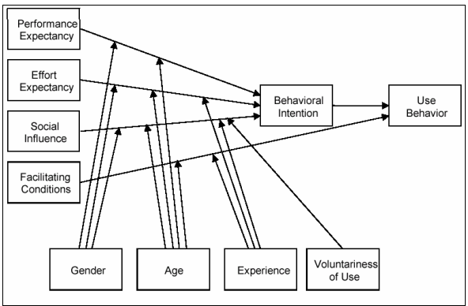

Figure 47: UTAUT model

The UTAUT model identifies behavioral intentions and uses behaviors by observing and analyzing the effects of individual differences, including gender, age, experience, and perceived willingness to use.

### Performance Expectancy Data Collection

There are two sections to this questionnaire. The first section will contain demographic data, while the second section will identify the influence of UTAUT.

|  |  |
| --- | --- |
| **PE (Performance Expectancy):**  **PE is used to gauge how much people believe that utilizing this system will enhance their ability to accomplish their jobs. PE prioritizes completing quests and is heavily influenced by Man.** | |
| PE01: | I find the mobile library management system very useful, through booking books and borrowing books and so on. |
| PE02: | By using the mobile library management system I can enjoy the convenience of a book review program. |
| PE03: | I can borrow books efficiently using the mobile library management system application. |
| PE04: | The books section information motivates me to use the mobile Library Management System application. |
| PE05: | I believe that using the mobile library management system application can improve my reservation and borrowing progress. |

Table 3: Performance Expectancy Evaluation

|  |  |
| --- | --- |
| **EE (Effort Expectancy): EE is used to explore how to make systems that people use and accept simpler.** | |
| EE01: | The use of the mobile library management system application is not characterized by stress. |
| EE02: | I do not require much technical knowledge to use the mobile library management system application. |
| EE03: | The use of the mobile library management system application reduces time and effort. |
| EE04: | The use of the mobile library management system application is not frustrating. |

Table 4: Effort Expectancy Evaluation

|  |  |
| --- | --- |
| **FC (Facilitating conditions): It is crucial to aid and support organizational management efforts by using FC to determine the influence on application usage.** | |
| FC01: | The library encourages the use of mobile library management system applications. |
| FC02: | Limited Internet connection and inadequate bandwidth in my university do not motivate me to use mobile library management system applications. |
| FC03: | I find it very convenient to use the mobile library management system to book and borrow books etc. |

Table 5: Facilitating Conditions Evaluation

### 5.3.2 Hypotheses Development

**H1**: Performance expectations have a positive impact on user behavior in adopting a mobile library management system.

**H2:** Efforts are expected to have a positive impact on user adoption of mobile library management systems.

**H3:** Facilitation conditions have a positive impact on users' behavior in adopting mobile library management systems.

Internal consistency reliability was determined using composite reliability (CR) and Cronbach's alpha. The measurement of various items on the same test is known as internal consistency reliability. It calculates Cronbach's alpha to check if the findings produce similar scores by measuring all item variance. It is advised that both CR and Cronbach's alpha values be higher than 0.7.

### 5.3.3 User Acceptance Test

This survey has been conducted through the UTAUT model. This survey aims to test user acceptance of the mobile library management system application and find out which part can be improved in future development. This study is carried out at UCSI University and took about 15 respondents to take part in this survey.

Throughout the survey, there is 73.3% of the respondents are aged range 18 to 25, and 26.7% of the respondents are around 26 to 30. 60% of the respondents are Male and 40% are Female.

Cronbach’s alpha (α)

The formula used to find Cronbach's alpha value is:

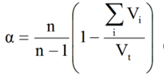

Figure 48: Cronbach’s Alpha Formula

To find Cronbach's alpha value, first should find every question’s variance.



Figure 49: Variance formula

**Performance Expectancy section:**

|  |  |
| --- | --- |
| Question | Variance |
| 1 | 0.4028 |
| 2 | 0.8339 |
| 3 | 0.4028 |
| 4 | 1.1195 |
| 5 | 0.6952 |

Table 6: Performance Expectancy variance

**The variance of the Performance Expectancy Section is: 15.5536**

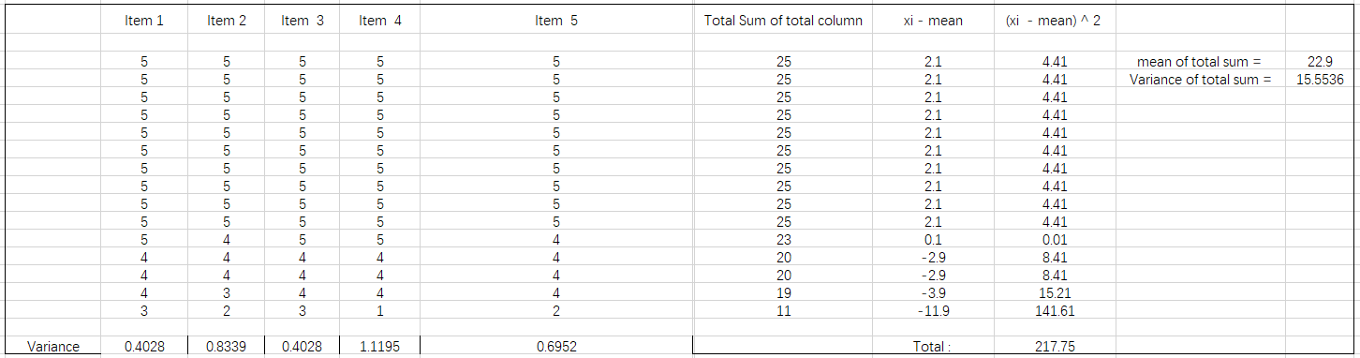

Figure 50: Total Column Variance of Performance Expectancy

The Cronbach’s alpha value of the Performance Expectancy is:

a = ( 5 / 4) ( (15.5536 – 3.4542) / 15.5536),

a = 0.9724

Fulfill the minimum acceptance requirement.

**Effort Expectancy section:**

|  |  |
| --- | --- |
| **Question** | **Variance** |
| **1** | **0.2095** |
| **2** | **0.4** |
| **3** | **0.4094** |
| **4** | **1.1143** |

Table 7: Effort Expectancy variance

**The variance of the Effort Expectancy: 6.9238**

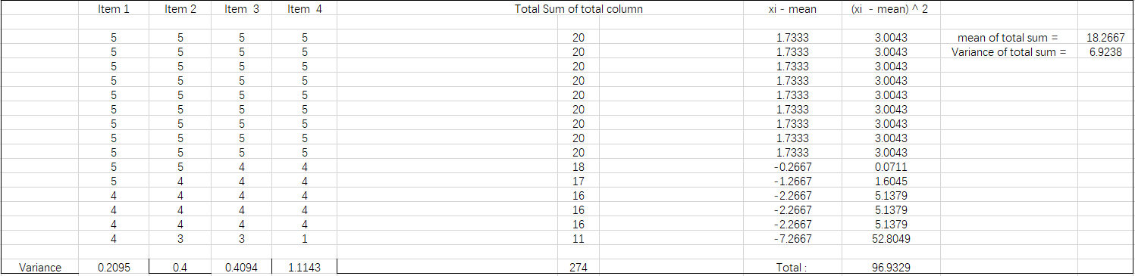

Figure 51: Total Column Variance of Effort Expectancy

The Cronbach’s alpha value of the Performance Expectancy is:

a = ( 4 / 3) ( (6.9238 – 2.1332) / 6.9238),

a = 0.9225

Fulfill the minimum acceptance requirement.

**Facilitating Conditions section:**

|  |  |
| --- | --- |
| **Question** | **Variance** |
| **1** | **0.5524** |
| **2** | **0.8286** |
| **3** | **0.4095** |

Table 8: Effort Expectancy variance

**The variance of the Facilitating Conditions: 5.1143**

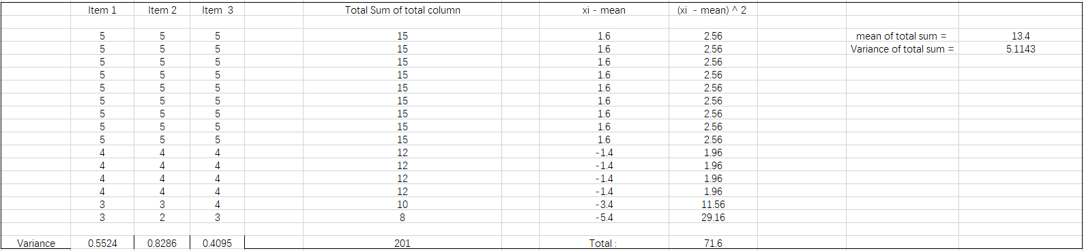

Figure 52: Total Column Variance of Facilitating Conditions

The Cronbach’s alpha value of the Performance Expectancy is:

a = ( 3 / 2) ( (5.1143– 1.7905) / 5.1143),

a = 0.9749

Fulfill the minimum acceptance requirement.

Based on the above results, this application has been accepted by the majority of UCSI students and it is believed that this application will help the library and users and bring closer relationships.

## 5.4 Chapter Summary

This chapter evaluates the work done to complete the project, and in system tests and test cases, all necessary tests are performed to ensure application quality. In the performance evaluation and user experience survey conducted through the UTAUT model, which was designed to test user acceptance of the mobile library management system, the results showed that the application has been accepted by the majority of UCSI students and is in future development Need to continue to improve to meet user expectations.

# CHAPTER 6: CONCLUSION AND RECOMMENDATION

## Chapter Introduction

This chapter summarizes the contributions of this project, the limitations of the study, and recommendations for future work. Conclusions are contained in Section 6.2, while study limitations are contained in Section 6.3. Section 6.4 is future work, Section 6.5 is Contribution to society, and Section 6.6 is a summary of the chapters.

## Conclusion

Nowadays, mobile devices have become the devices that almost every modern person owns, and they are used in all aspects of life, including work, entertainment, and communication. I believe that mobile library will become the future trend of the world because it brings a lot of conveniences. By using the mobile library management system, users can easily perform operations such as borrowing, making reservations, and reporting book loss, and librarians can easily track book-related information and properly handle the management process. Through the book review program, let users and administrators form interactive management. The system establishes the connection between the user and the library through the mobile device, establishes the connection between the user and the user, and establishes the connection between the user and the librarian. The interaction will be beneficial to the development of the entire mobile library management system.

## The Limitations of The Study

Although most of the goals of this study have been achieved, there are still many deficiencies. The system design is somewhat simple. The book review function is not very perfect, and other users cannot directly participate in the discussion under a book review.

In addition, due to cost constraints, the development of this project uses a basic server, which causes some page jumps to be delayed. When entering book information, librarians cannot import and upload book information in batches. There is no forgot password function in the background management interface, which may cause some trouble.

## Future Works

Although the system has been satisfied by most people, it still has a lot of room for improvement. The system will realize more and more perfect functions in the future. Its interface design will need to accommodate mobile devices of various sizes so that it can be more attractive to users. In the future, the language of the system may be multiple to suit the use of people in different countries and regions. In the future, librarians will be supported to upload book information in large quantities, and comments between users can be directly replied so that users can communicate directly.

## 6.5 Contribution to Society

By using this system, users can borrow, reserve, return, report lost books and other operations using mobile devices at any place and at any time. They do not have to worry about the loss of relevant information, all data will be securely and quickly transferred to the database. In addition, users can track the information of favorite books through the system and check whether there are any more books. The administrator side can make changes to the system functions. For example, edit book categories, edit book information, edit announcements, etc. Administrators can perform all tasks of the system and save a lot of time.

## 6.6 Chapter Summary

This chapter summarizes the findings and contributions of the project. This chapter also examines some limitations of this study, which provides some ideas for future research, which will help researchers to further improve this system.

# REFERENCES

[1] G. Goggin, *Cell phone culture: Mobile technology in everyday life*. Routledge, 2006.

[2] J.-H. Valk, A. T. Rashid, L. J. I. R. o. R. i. O. Elder, and D. Learning, "Using mobile phones to improve educational outcomes: An analysis of evidence from Asia," vol. 11, no. 1, pp. 117-140, 2010.

[3] H. Heflin, J. Shewmaker, J. J. C. Nguyen, and education, "Impact of mobile technology on student attitudes, engagement, and learning," vol. 107, pp. 91-99, 2017.

[4] P. Thornton and C. J. J. o. c. a. l. Houser, "Using mobile phones in English education in Japan," vol. 21, no. 3, pp. 217-228, 2005.

[5] S. R. Nalluri and B. J. I. J. o. R. i. L. S. Gaddam, "Mobile library services and technologies: A study," vol. 2, no. 2, pp. 59-66, 2016.

[6] W. Stats, "World Internet Users Statistics And 2020 World Population Stats," 2020.

[7] S. M. Isa, L. Kelly, S. J. I. J. o. P. M. Kiumarsi, and Benchmarking, "Brand switching through marketing mix: the role of brand effect on smartphone users," vol. 10, no. 3, pp. 419-438, 2020.

[8] A. Prabowo, U. Rahmawati, and R. P. J. I. J. o. E. M. E. Anggoro, "Android-based teaching material for statistics integrated with social media WhatsApp," vol. 3, no. 1, pp. 93-104, 2019.

[9] Q. Zhang, S. Yang, and R. Ren, "Research on Uni-app Based Cross-platform Digital Textbook System," in *Proceedings of the 2020 3rd International Conference on Computer Science and Software Engineering*, 2020, pp. 52-57.

[10] B. J. G. t. K. V. j. Nelson, "Getting to Know Vue. js," 2018.

[11] B. B. Moran and C. J. Morner, *Library and information center management*. ABC-CLIO, 2017.

[12] H. Lim, S. J. J. o. A. A. Kim, and B. Engineering, "Changes in spatial organization in French public libraries," vol. 8, no. 2, pp. 323-330, 2009.

[13] T.-T. J. N. e. t. Wu, "Using smart mobile devices in social-network-based health education practice: A learning behavior analysis," vol. 34, no. 6, pp. 958-963, 2014.

[14] A. H. A. Al-Obaidi, "Design and Implementation of a Computerized Library Management System Using GUI," in *Next Generation of Internet of Things*: Springer, 2021, pp. 669-683.

[15] J. Rowley, *The electronic library*. Facet Publishing, 1998.

[16] H. Cheng, L. Huang, H. Xu, Y. Hu, and X. A. Wang, "Design and implementation of library books search and management system using RFID technology," in *2016 International conference on intelligent networking and collaborative systems (INCoS)*, 2016, pp. 392-397: IEEE.

[17] S. H. Choshaly and M. J. L. M. Mirabolghasemi, "Using SEM-PLS to assess users satisfaction of library service quality: Evidence from Malaysia," 2018.

[18] Notebookcheck. *Gartner report: Android dominates the smartphone market*. Available: <https://www.notebookcheck.net/Gartner-report-Android-dominates-the-smartphone-market.148354.0.html>

[19] S. Malathy, P. J. D. J. o. L. Kantha, and I. Technology, "Application of mobile technologies to libraries," vol. 33, no. 5, 2013.

[20] A. T. Sorensen and S. J. J. N. W. P. Rasmussen, Stanford University, "Is any publicity good publicity? A note on the impact of book reviews," 2004.

[21] R. J. N. S. Watson, "Quantitative research," vol. 29, no. 31, p. 44, 2015.

[22] B. Gong, D. C. Yen, D. C. J. I. M. Chou, and D. Systems, "A manager’s guide to total quality software design," vol. 98, no. 3, pp. 100-107, 1998.

[23] "UCSI University Object-Oriented Modeling," *Object-Oriented Modeling Lecture Slide Chapter 2,* pp. 1-24.

[24] J. Noll, M. A. Razzak, J. M. Bass, and S. Beecham, "A study of the scrum master’s role," in *International Conference on Product-Focused Software Process Improvement*, 2017, pp. 307-323: Springer.

[25] R. J. M. T. Japenga, Inc, "How to write a software requirements specification," 2003.

[26] B. Taraghi, A. Azmi, and O. Yusop, "Producing Software Engineering Documents through Software Reverse Engineering for Node. js Web Application."

[27] A. J. S. J. Rini, "Analisis Hasil Pemanfaatan Media Pembelajaran Interaktif Aljabar Logika Dengan User Acceptance Test (UAT)," vol. 8, no. 02, pp. 67-73, 2018.

[28] A. L. A. Brian, L. Arockiam, P. J. I. J. o. E. T. i. C. S. Malarchelvi, and Electronics, "An IOT based secured smart library system with NFC based book tracking," vol. 11, no. 5, pp. 18-21, 2014.

[29] C. Srujana *et al.*, "Development of RFID based library management system using MATLAB," vol. 2, no. 5, pp. 480-483, 2013.

[30] M. J. I. E. S. Niqresh, "Digital Library and Intellectual Issues--Issues in Copyright and Intellectual Property," vol. 12, no. 1, pp. 114-127, 2019.

[31] B. J. P. l. q. Kinney, "The internet, public libraries, and the digital divide," vol. 29, no. 2, pp. 104-161, 2010.

[32] M. J. J. o. W. L. Eaton, "Seeing library data: A prototype data visualization application for librarians," vol. 11, no. 1, pp. 69-78, 2017.

[33] Z. Li, "The Design and Application of GIS Mathematical Model Database System with Meta-algorithm," in *2015 4th National Conference on Electrical, Electronics and Computer Engineering*, 2015, pp. 1166-1170: Atlantis Press.

[34] S. Liu and X.-L. J. L. H. T. Shen, "Library management and innovation in the Big Data Era," 2018.

[35] O. K. Udem and B. J. n. A. Onwurah, "Digitization of Library Resources in University Libraries: A Practical Approach, Challenges and Prospects," 2019.

[36] W. Yuan, M. Van Ballegooie, and J. L. J. C. M. Robertson, "Ebooks versus print books: Format preferences in an academic library," vol. 43, no. 1, pp. 28-48, 2018.

[37] J. E. J. J. o. L. Adkins and S. Communication, "Review of Along Came Google: A History of Library Digitization by Deanna Marcum and Roger C. Schonfeld," vol. 10, no. 1, 2022.

[38] G. E. Evans, *Developing Library and Information Center Collections. Library Science Text Series*. ERIC, 1995.

[39] M. J. J. o. A. i. L. Singh and I. Science, "A snapshot of traditional library to modern library using bar code technology: an experience of central library GNDEC, Ludhiana," vol. 3, no. 2, pp. 146-149, 2014.

[40] J. Kong, "Research on IT Management and Service of Small and Medium Sized Libraries Based on Cloud Computing and Virtualization Technology," *Journal of Physics: Conference Series,* vol. 1648, 2020.

[41] H. Supriyono and M. R. Fitriyan, "Developing a QR Code-based Library Management System with Case Study of Private School in Surakarta City Indonesia," in *2018 Third International Conference on Informatics and Computing (ICIC)*, 2018, pp. 1-6: IEEE.

[42] J. F. Zhang and C. J. Wen, "The university library management system based on radio frequency identification," in *2017 10th International Congress on Image and Signal Processing, BioMedical Engineering and Informatics (CISP-BMEI)*, 2017, pp. 1-6: IEEE.

[43] J. Hou, Z. Zhu, and J. Zong, "Design and realization of network-oriented library management system (LMS)," in *2012 IEEE Symposium on Robotics and Applications (ISRA)*, 2012, pp. 813-816: IEEE.

[44] G. S. Shada and M. A. Ayu, "Designing Android User Interface for University Mobile Library," in *2018 International Conference on Computing, Engineering, and Design (ICCED)*, 2018, pp. 224-229: IEEE.

[45] M. Wang, "The Building of Library Management System Based on Hibernate Model," in *2010 International Conference on Challenges in Environmental Science and Computer Engineering*, 2010, vol. 2, pp. 409-412: IEEE.

[46] A. Lalwani, "VESIT Library - An Android Based Application," *International Journal of Engineering and Computer,* vol. 6, pp. 22032-22035, 2017.

[47] E. E. Shumilak, "An online interactive book-library-management system," 1971.

[48] K. Ihejirika, "Social Media Strategies for Marketing in University Libraries: Undergraduate User Attitudes and Motivation for Engagement," 2021.

[49] M. J. J. I. I. Hossain and L. Review, "Redefining expectancy disconfirmation theory using LIS SERVQUAL+: An integrated framework for evaluating library service quality and user satisfaction," vol. 51, no. 3, pp. 203-216, 2019.

# APPENDIX Ⅰ:

**Pre-Development Survey:**

**Requirement Survey on Developing Mobile Library Management System**

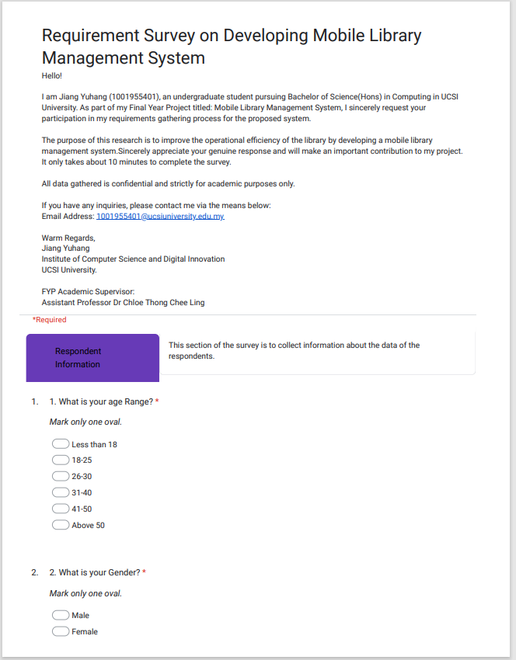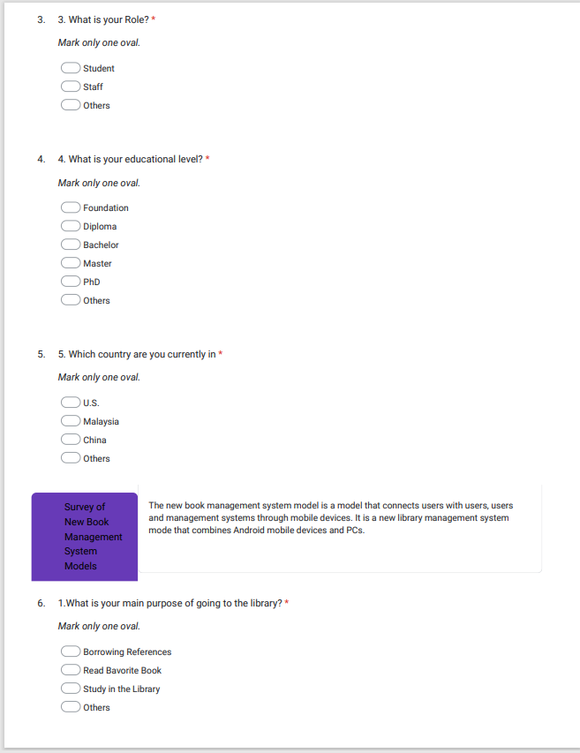

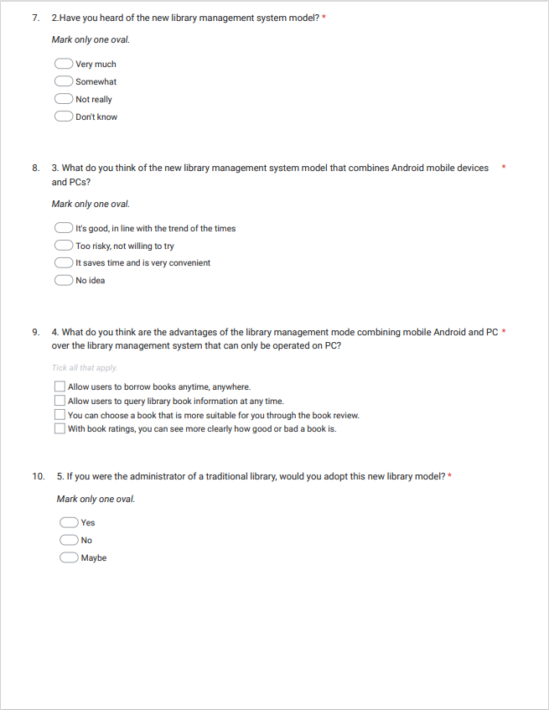

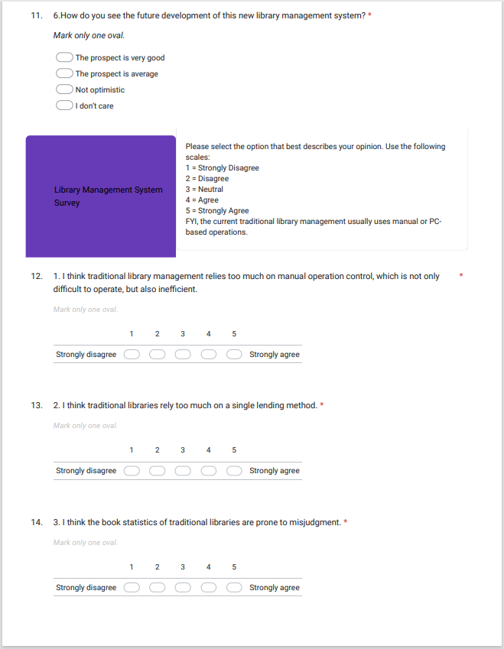

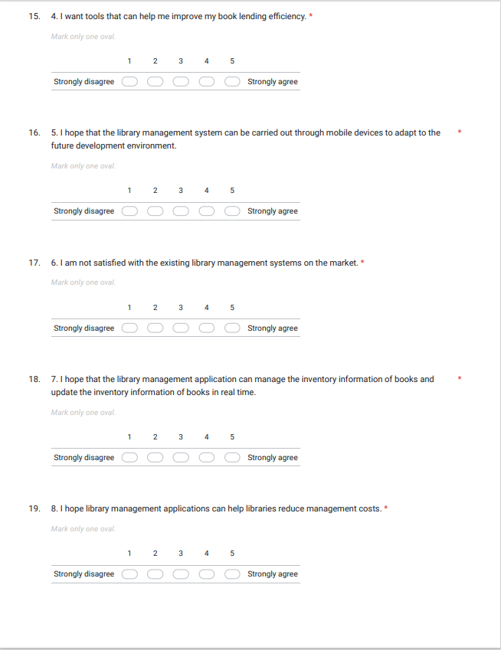

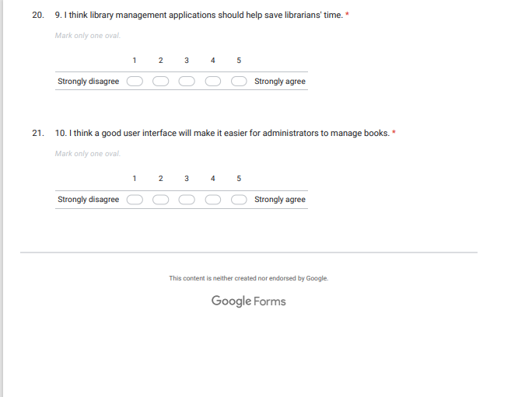

# APPENDIX Ⅱ:

**Post-Development Survey:**

**Performance Evaluation & User Experience Feedback on the Mobile Library Management System**

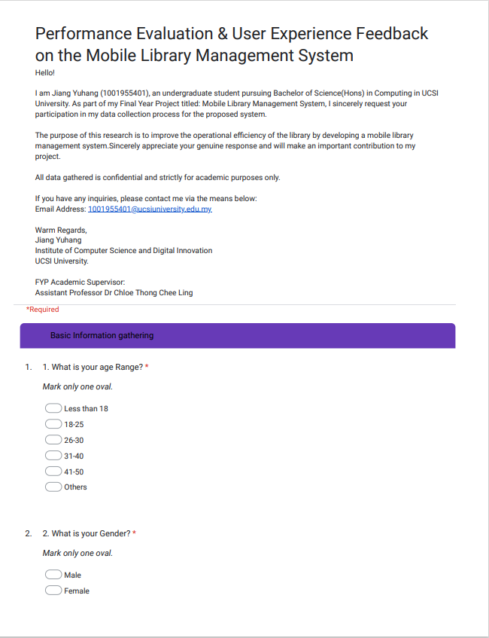

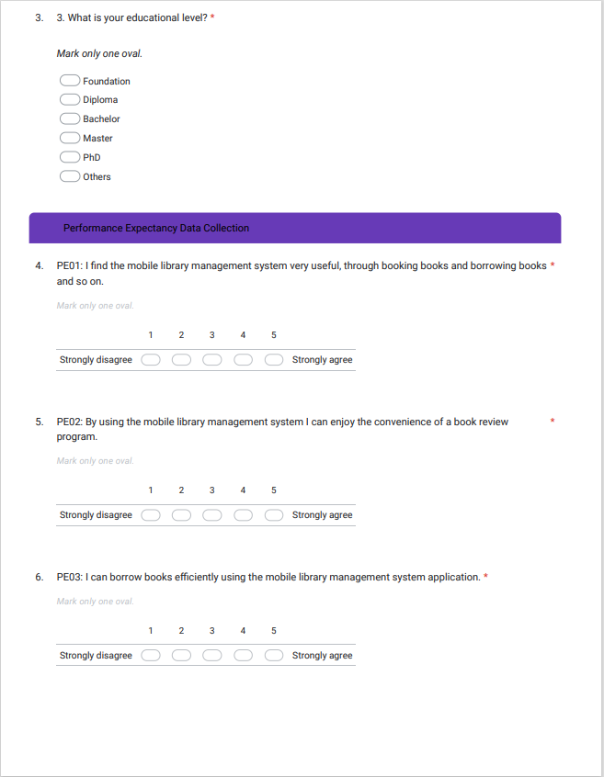

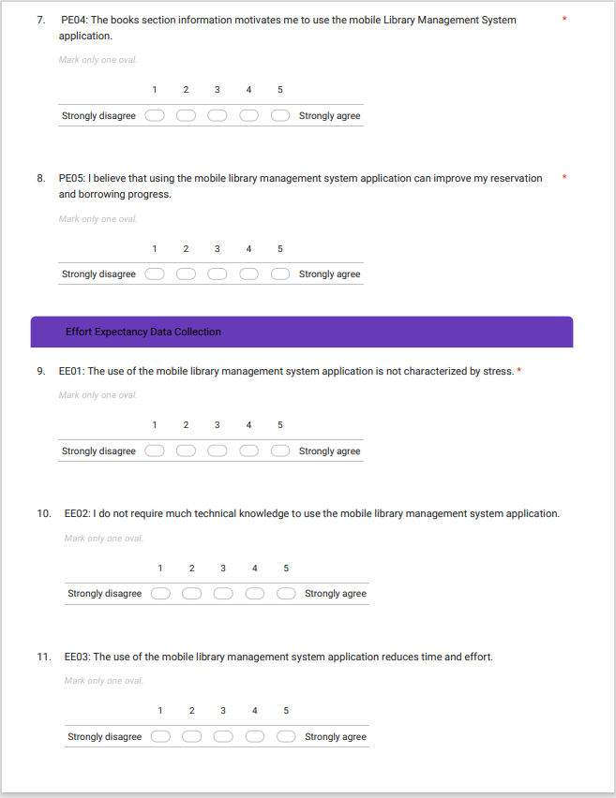

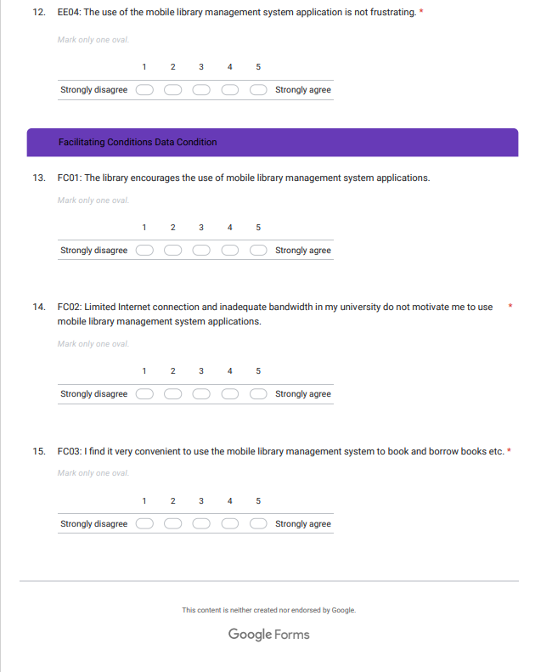

Variance data of Question:

Performance Expectancy

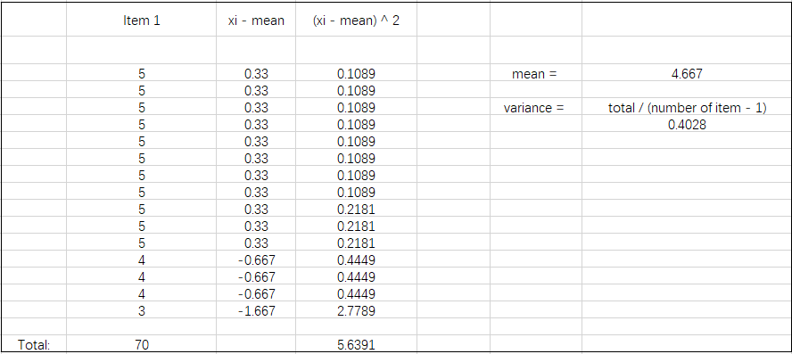

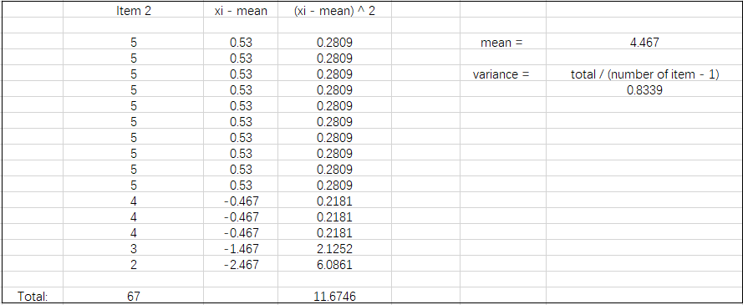

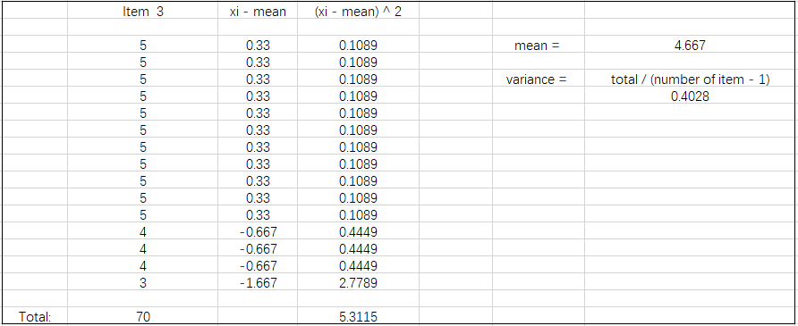

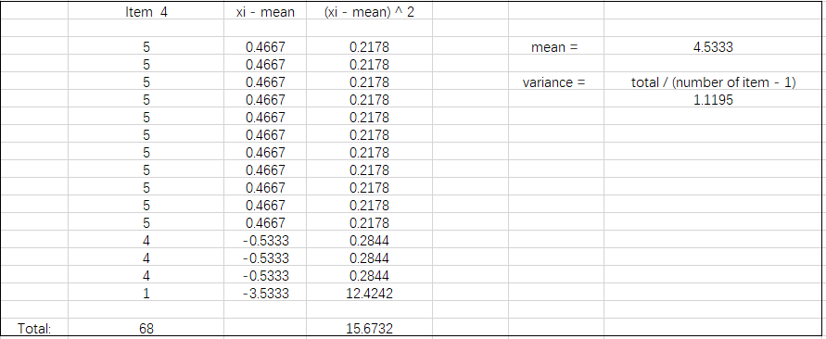

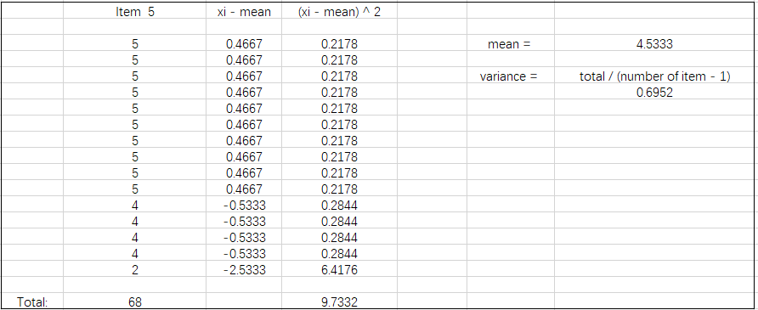

Effort Expectancy

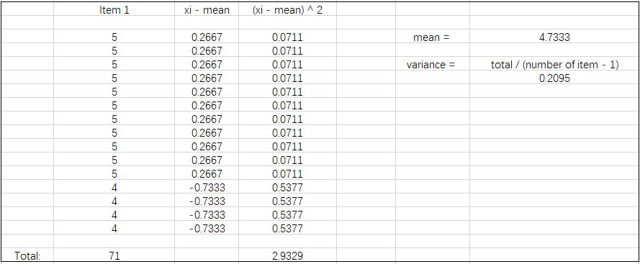

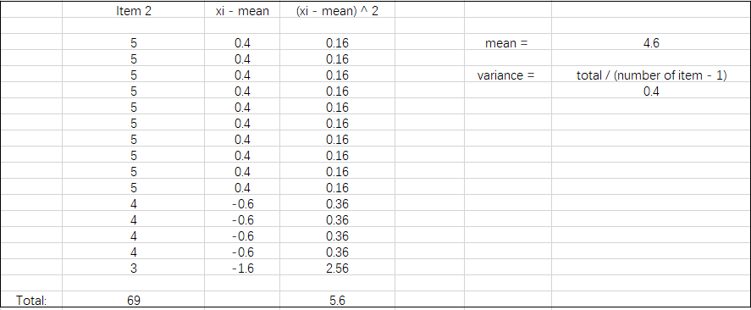

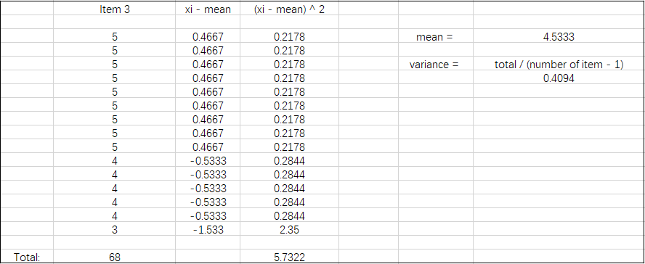

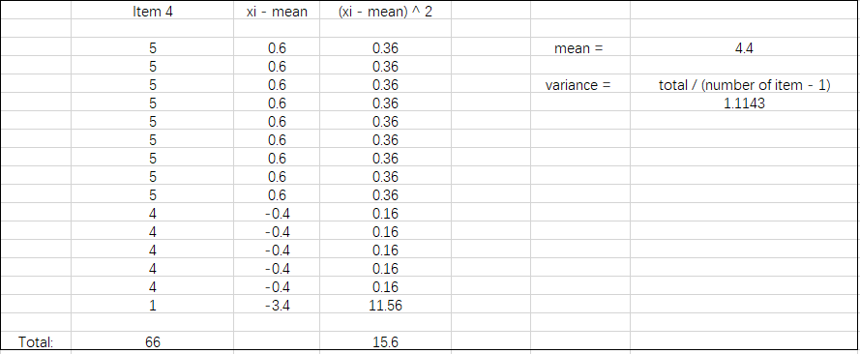

Facilitating Conditions

